God and His Covenant – Preparing Abraham for Chapter 22
Psalm 105:1 O give thanks unto the LORD; call upon his name: make known his deeds among the people.
Psalm 105:2 Sing unto him, sing psalms unto him: talk ye of all his wondrous works.
Psalm 105:3 Glory ye in his holy name: let the heart of them rejoice that seek the LORD.
Psalm 105:4 Seek the LORD, and his strength: seek his face evermore.
Psalm 105:5 Remember his marvellous works that he hath done; his wonders, and the judgments of his mouth;
Psalm 105:6 O ye seed of Abraham his servant, ye children of Jacob his chosen.
Psalm 105:7 He is the LORD our God: his judgments are in all the earth.
Psalm 105:8 He hath remembered his covenant for ever, the word which he commanded to a thousand generations.
Psalm 105:9 Which covenant he made with Abraham, and his oath unto Isaac;
Psalm 105:10 And confirmed the same unto Jacob for a law, and to Israel for an everlasting covenant:
Psalm 105:11 Saying, Unto thee will I give the land of Canaan, the lot of your inheritance:
Psalm 105:12 When they were but a few men in number; yea, very few, and strangers in it.
Genesis 20:1 And Abraham journeyed from thence toward the south country, and dwelled between Kadesh and Shur, and sojourned in Gerar. |  | 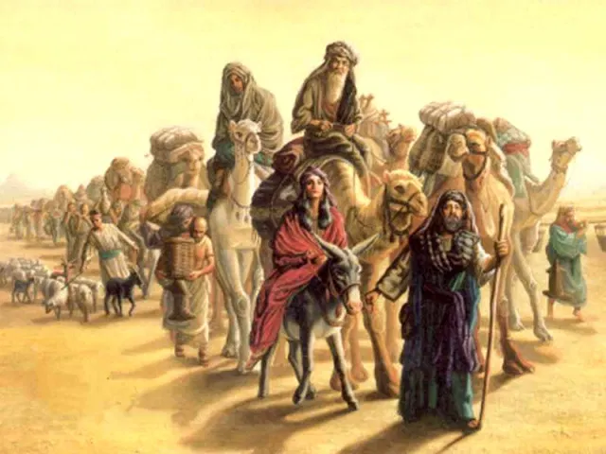
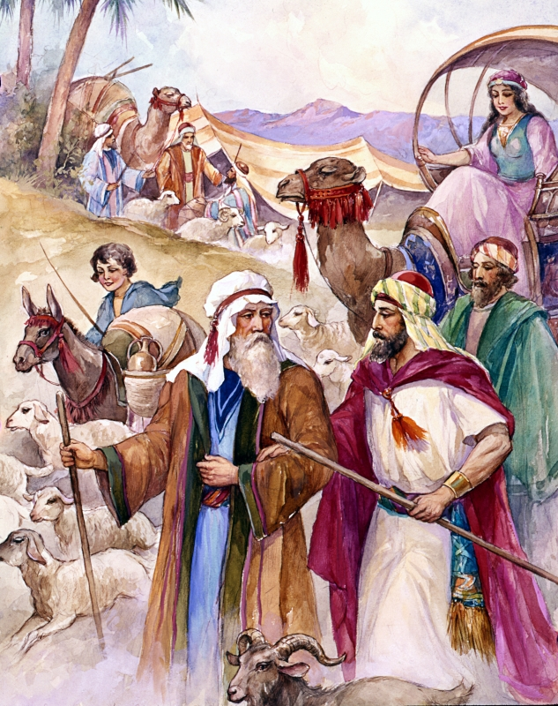 | Genesis 20:2 And Abraham said of Sarah his wife, She is my sister: and Abimelech king of Gerar sent, and took Sarah.  Genesis 20:3 But God came to Abimelech in a dream by night, and said to him, Behold, thou art but a dead man, for the woman which thou hast taken; for she is a man's wife.  Genesis 20:4 But Abimelech had not come near her: and he said, Lord, wilt thou slay also a righteous nation?  Genesis 20:5 Said he not unto me, She is my sister? and she, even she herself said, He is my brother: in the integrity of my heart and innocency of my hands have I done this.  Genesis 20:6 And God said unto him in a dream, Yea, I know that thou didst this in the integrity of thy heart; for I also withheld thee from sinning against me: therefore suffered I thee not to touch her.  Genesis 20:7 Now therefore restore the man his wife; for he is a prophet, and he shall pray for thee, and thou shalt live: and if thou restore her not, know thou that thou shalt surely die, thou, and all that are thine.

Abimelech is in Trouble – Needs Healing
Genesis 20:8 Therefore Abimelech rose early in the morning, and called all his servants, and told all these things in their ears: and the men were sore afraid.
Genesis 20:9 Then Abimelech called Abraham, and said unto him, What hast thou done unto us? and what have I offended thee, that thou hast brought on me and on my kingdom a great sin? thou hast done deeds unto me that ought not to be done.
Genesis 20:10 And Abimelech said unto Abraham, What sawest thou, that thou hast done this thing?
Genesis 20:11 And Abraham said, Because I thought, Surely the fear of God is not in this place; and they will slay me for my wife's sake.
Genesis 20:12 And yet indeed she is my sister; she is the daughter of my father, but not the daughter of my mother; and she became my wife.
Genesis 20:13 And it came to pass, when God caused me to wander from my father's house, that I said unto her, This is thy kindness which thou shalt shew unto me; at every place whither we shall come, say of me, He is my brother.
Genesis 20:14 And Abimelech took sheep, and oxen, and menservants, and womenservants, and gave them unto Abraham, and restored him Sarah his wife.
Abimelech Reproves Sarah
Genesis 20:15 And Abimelech said, Behold, my land is before thee: dwell where it pleaseth thee.
Genesis 20:16 And unto Sarah he said, Behold, I have given thy brother a thousand pieces of silver: behold, he is to thee a covering of the eyes, unto all that are with thee, and with all other: thus she was reproved.
Abraham Prays and Abimelech is healed
Genesis 20:17 So Abraham prayed unto God: and God healed Abimelech, and his wife, and his maidservants; and they bare children.
Genesis 20:18 For the LORD had fast closed up all the wombs of the house of Abimelech, because of Sarah Abraham's wife.
Genesis 21:1 And the LORD visited Sarah as he had said, and the LORD did unto Sarah as he had spoken.  Genesis 21:2 For Sarah conceived, and bare Abraham a son in his old age, at the set time of which God had spoken to him.  Genesis 21:3 And Abraham called the name of his son that was born unto him, whom Sarah bare to him, Isaac.  Genesis 21:4 And Abraham circumcised his son Isaac being eight days old, as God had commanded him.  Genesis 21:5 And Abraham was an hundred years old, when his son Isaac was born unto him. |  | 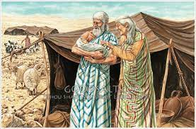
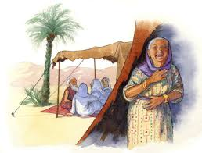 | Genesis 21:6 And Sarah said, God hath made me to laugh, so that all that hear will laugh with me.  Genesis 21:7 And she said, Who would have said unto Abraham, that Sarah should have given children suck? for I have born him a son in his old age.  Genesis 21:8 And the child grew, and was weaned: and Abraham made a great feast the same day that Isaac was weaned.
Trouble between Sarah and Hagar  Genesis 21:9 And Sarah saw the son of Hagar the Egyptian, which she had born unto Abraham, mocking.  Genesis 21:10 Wherefore she said unto Abraham, Cast out this bondwoman and her son: for the son of this bondwoman shall not be heir with my son, even with Isaac. |  |  | 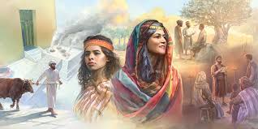
Genesis 21:11 And the thing was very grievous in Abraham's sight because of his son.
Genesis 21:12 And God said unto Abraham, Let it not be grievous in thy sight because of the lad, and because of thy bondwoman; in all that Sarah hath said unto thee, hearken unto her voice; for in Isaac shall thy seed be called.
Genesis 21:13 And also of the son of the bondwoman will I make a nation, because he is thy seed.
Genesis 21:14 And Abraham rose up early in the morning, and took bread, and a bottle of water, and gave it unto Hagar, putting it on her shoulder, and the child, and sent her away: and she departed, and wandered in the wilderness of Beer-sheba.
Genesis 21:15 And the water was spent in the bottle, and she cast the child under one of the shrubs.
Genesis 21:16 And she went, and sat her down over against him a good way off, as it were a bowshot: for she said, Let me not see the death of the child. And she sat over against him, and lift up her voice, and wept.

God Hears the Voice of the Lad
Genesis 21:17 And God heard the voice of the lad; and the angel of God called to Hagar out of heaven, and said unto her, What aileth thee, Hagar? fear not; for God hath heard the voice of the lad where he is.
Genesis 21:18 Arise, lift up the lad, and hold him in thine hand; for I will make him a great nation.
Genesis 21:19 And God opened her eyes, and she saw a well of water; and she went, and filled the bottle with water, and gave the lad drink.
Genesis 21:20 And God was with the lad; and he grew, and dwelt in the wilderness, and became an archer.
Genesis 21:21 And he dwelt in the wilderness of Paran: and his mother took him a wife out of the land of Egypt.
Abimelech Knows God is with Abraham
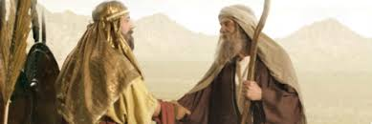 |  | Genesis 21:22 And it came to pass at that time, that Abimelech and Phichol the chief captain of his host spake unto Abraham, saying, God is with thee in all that thou doest:
Genesis 21:23 Now therefore swear unto me here by God that thou wilt not deal falsely with me, nor with my son, nor with my son's son: but according to the kindness that I have done unto thee, thou shalt do unto me, and to the land wherein thou hast sojourned.
Genesis 21:24 And Abraham said, I will swear.
Abraham Reproves Abimelech
Genesis 21:25 And Abraham reproved Abimelech because of a well of water, which Abimelech's servants had violently taken away.
Genesis 21:26 And Abimelech said, I wot not who hath done this thing: neither didst thou tell me, neither yet heard I of it, but to day.
Genesis 21:27 And Abraham took sheep and oxen, and gave them unto Abimelech; and both of them made a covenant.
Genesis 21:28 And Abraham set seven ewe lambs of the flock by themselves.
Genesis 21:29 And Abimelech said unto Abraham, What mean these seven ewe lambs which thou hast set by themselves?  Genesis 21:30 And he said, For these seven ewe lambs shalt thou take of my hand, that they may be a witness unto me, that I have digged this well.  Genesis 21:31 Wherefore he called that place Beer-sheba; because there they sware both of them.  Genesis 21:32 Thus they made a covenant at Beer-sheba: then Abimelech rose up, and Phichol the chief captain of his host, and they returned into the land of the Philistines. |  |  | 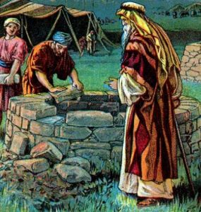
Abraham Worships God  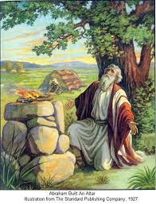 | Genesis 21:33 And Abraham planted a grove in Beer-sheba, and called there on the name of the LORD, the everlasting God.  Genesis 21:34 And Abraham sojourned in the Philistines' land many days.

Isaac’s Birth a Type of The Birth of Christ
Isaac’s Birth | Christ’s Birth
Isaac’s birth was miraculous against nature – Genesis 18:11; Romans 4:18-19; Hebrews 11:11 | Christ was born of a virgin – against nature - Matthew 1:20&21; Isaiah 7:14
Isaac was promised long before he was born, 25 years went by - Genesis 12:1-3 | Jesus was promised many, many years before. – 4000 years went by Genesis 3:15; Isaiah 7:14
Isaac’s birth seemed delayed, but He was born at God’s appointed time. - Genesis 21:1&2 | His birth seemed delayed, but He was born at God’s appointed time.- Galatians 4:4
Isaac’s name was announced before he was born - Genesis 17:19 | Jesus’ name was announced before he was born - Matthew 1:20&21
Abraham was confused when God promised him a son in his old age, his wife was passed the years of child bearing. - Genesis 17:15-17 | When Joseph found Mary with child, he was equally confused, his wife not being with a man - Matthew 1:19-20
Sarah, before her supernaturally conceived son was born, thought it to be impossible – Genesis 18:13 | Mary, before her supernaturally conceived son was born, thought it to be impossible - Luke 1:34
The Angel – (God) – announced to Sarah Genesis 18:14: “Is any thing too hard for the Lord?” | The angel announced to Mary Luke 1:37 For with God nothing shall be impossible.

Let’s look at Psalm 105 again in light of God’s covenant with Abraham
Psalm 105:1 O give thanks unto the LORD; call upon his name: make known his deeds among the people.
Psalm 105:2 Sing unto him, sing psalms unto him: talk ye of all his wondrous works.
Psalm 105:3 Glory ye in his holy name: let the heart of them rejoice that seek the LORD.
Psalm 105:4 Seek the LORD, and his strength: seek his face evermore.
Psalm 105:5 Remember his marvellous works that he hath done; his wonders, and the judgments of his mouth;
Psalm 105:6 O ye seed of Abraham his servant, ye children of Jacob his chosen.
Psalm 105:7 He is the LORD our God: his judgments are in all the earth.
Psalm 105:8 He hath remembered his covenant for ever, the word which he commanded to a thousand generations.
Psalm 105:9 Which covenant he made with Abraham, and his oath unto Isaac;
Psalm 105:10 And confirmed the same unto Jacob for a law, and to Israel for an everlasting covenant:
Psalm 105:11 Saying, Unto thee will I give the land of Canaan, the lot of your inheritance:
Psalm 105:12 When they were but a few men in number; yea, very few, and strangers in it.
Psalm 105:13 When they went from one nation to another, from one kingdom to another people;
Psalm 105:14 He suffered no man to do them wrong: yea, he reproved kings for their sakes;
Psalm 105:15 Saying, Touch not mine anointed, and do my prophets no harm.
We Must Cast Out the Bond Woman - We were in bondage under the elements of the world
Galatians 4:1 Now I say, That the heir, as long as he is a child, differeth nothing from a servant, though he be lord of all;
Galatians 4:2 But is under tutors and governors until the time appointed of the father.
Galatians 4:3 Even so we, when we were children, were in bondage under the elements of the world:
God sent forth His Son at His own appointed time
Galatians 4:4 But when the fulness of the time was come, God sent forth his Son, made of a woman, made under the law,
Why?
Galatians 4:5 To redeem them that were under the law, that we might receive the adoption of sons.
Galatians 4:6 And because ye are sons, God hath sent forth the Spirit of his Son into your hearts, crying, Abba, Father.
Galatians 4:7 Wherefore thou art no more a servant, but a son; and if a son, then an heir of God through Christ.
Probably did not know we were serving other gods
Galatians 4:8 Howbeit then, when ye knew not God, ye did service unto them which by nature are no gods.
But now ye have known God – Don’t turn back to religion
Galatians 4:9 But now, after that ye have known God, or rather are known of God, how turn ye again to the weak and beggarly elements, whereunto ye desire again to be in bondage?
Galatians 4:10 Ye observe days, and months, and times, and years.
Galatians 4:11 I am afraid of you, lest I have bestowed upon you labour in vain.
Don’t put yourself back into bondage
Galatians 4:12 Brethren, I beseech you, be as I am; for I am as ye are: ye have not injured me at all.
Galatians 4:13 Ye know how through infirmity of the flesh I preached the gospel unto you at the first.
Galatians 4:14 And my temptation which was in my flesh ye despised not, nor rejected; but received me as an angel of God, even as Christ Jesus.
Galatians 4:15 Where is then the blessedness ye spake of? for I bear you record, that, if it had been possible, ye would have plucked out your own eyes, and have given them to me.
Galatians 4:16 Am I therefore become your enemy, because I tell you the truth?
Galatians 4:17 They zealously affect you, but not well; yea, they would exclude you, that ye might affect them.
Galatians 4:18 But it is good to be zealously affected always in a good thing, and not only when I am present with you.
Paul says he travails in birth
Galatians 4:19 My little children, of whom I travail in birth again until Christ be formed in you,
Galatians 4:20 I desire to be present with you now, and to change my voice; for I stand in doubt of you.
Galatians 4:21 Tell me, ye that desire to be under the law, do ye not hear the law?
Abraham had two sons – An Allegory
Galatians 4:22 For it is written, that Abraham had two sons, the one by a bondmaid, the other by a freewoman.
Galatians 4:23 But he who was of the bondwoman was born after the flesh; but he of the freewoman was by promise.
Galatians 4:24 Which things are an allegory: for these are the two covenants; the one from the mount Sinai, which gendereth to bondage, which is Agar.
Galatians 4:25 For this Agar is mount Sinai in Arabia, and answereth to Jerusalem which now is, and is in bondage with her children.
Galatians 4:26 But Jerusalem which is above is free, which is the mother of us all.
Galatians 4:27 For it is written, Rejoice, thou barren that bearest not; break forth and cry, thou that travailest not: for the desolate hath many more children than she which hath an husband.
Galatians 4:28 Now we, brethren, as Isaac was, are the children of promise.
Galatians 4:29 But as then he that was born after the flesh persecuted him that was born after the Spirit, even so it is now.
Nevertheless what saith Scripture
Galatians 4:30 Nevertheless what saith the scripture? Cast out the bondwoman and her son: for the son of the bondwoman shall not be heir with the son of the freewoman.
Galatians 4:31 So then, brethren, we are not children of the bondwoman, but of the free.
See that ye refuse not Him that Speaketh
Let us lay aside every weight
Hebrews 12:1 Wherefore seeing we also are compassed about with so great a cloud of witnesses, let us lay aside every weight, and the sin which doth so easily beset us, and let us run with patience the race that is set before us,
Look unto Jesus – the Author and Finisher of our faith
Hebrews 12:2 Looking unto Jesus the author and finisher of our faith; who for the joy that was set before him endured the cross, despising the shame, and is set down at the right hand of the throne of God.
Hebrews 12:3 For consider him that endured such contradiction of sinners against himself, lest ye be wearied and faint in your minds.
Endure God’s chastening
Hebrews 12:4 Ye have not yet resisted unto blood, striving against sin.
Hebrews 12:5 And ye have forgotten the exhortation which speaketh unto you as unto children, My son, despise not thou the chastening of the Lord, nor faint when thou art rebuked of him:
Hebrews 12:6 For whom the Lord loveth he chasteneth, and scourgeth every son whom he receiveth.
Hebrews 12:7 If ye endure chastening, God dealeth with you as with sons; for what son is he whom the father chasteneth not?
Hebrews 12:8 But if ye be without chastisement, whereof all are partakers, then are ye bastards, and not sons.
As our earthly fathers chastised us
Hebrews 12:9 Furthermore we have had fathers of our flesh which corrected us, and we gave them reverence: shall we not much rather be in subjection unto the Father of spirits, and live?
Hebrews 12:10 For they verily for a few days chastened us after their own pleasure; but he for our profit, that we might be partakers of his holiness.
Hebrews 12:11 Now no chastening for the present seemeth to be joyous, but grievous: nevertheless afterward it yieldeth the peaceable fruit of righteousness unto them which are exercised thereby.
Make straight the paths of your feet
Hebrews 12:12 Wherefore lift up the hands which hang down, and the feeble knees;
Hebrews 12:13 And make straight paths for your feet, lest that which is lame be turned out of the way; but let it rather be healed.
Hebrews 12:14 Follow peace with all men, and holiness, without which no man shall see the Lord:
Looking diligently lest any man fail the grace of God
Hebrews 12:15 Looking diligently lest any man fail of the grace of God; lest any root of bitterness springing up trouble you, and thereby many be defiled;
Hebrews 12:16 Lest there be any fornicator, or profane person, as Esau, who for one morsel of meat sold his birthright.
Hebrews 12:17 For ye know how that afterward, when he would have inherited the blessing, he was rejected: for he found no place of repentance, though he sought it carefully with tears.
Now, we will contrast Sanai and Zion – (Free woman and bond woman of Galatians 4)
Hebrews 12:18 For ye are not come unto the mount that might be touched, and that burned with fire, nor unto blackness, and darkness, and tempest,
Hebrews 12:19 And the sound of a trumpet, and the voice of words; which voice they that heard intreated that the word should not be spoken to them any more:
Hebrews 12:20 (For they could not endure that which was commanded, And if so much as a beast touch the mountain, it shall be stoned, or thrust through with a dart:
Hebrews 12:21 And so terrible was the sight, that Moses said, I exceedingly fear and quake:)
But we are come to Mount Zion -
Hebrews 12:22 But ye are come unto mount Sion, and unto the city of the living God, the heavenly Jerusalem, and to an innumerable company of angels,
Hebrews 12:23 To the general assembly and church of the firstborn, which are written in heaven, and to God the Judge of all, and to the spirits of just men made perfect,
Hebrews 12:24 And to Jesus the mediator of the new covenant, and to the blood of sprinkling, that speaketh better things than that of Abel.
Remember Hebrews 1 – Who is it that is speaketh?
Hebrews 12:25 See that ye refuse not him that speaketh. For if they escaped not who refused him that spake on earth, much more shall not we escape, if we turn away from him that speaketh from heaven:
He is going to shake this earth again – Don’t refuse Him that speaketh
Hebrews 12:26 Whose voice then shook the earth: but now he hath promised, saying, Yet once more I shake not the earth only, but also heaven.
Hebrews 12:27 And this word, Yet once more, signifieth the removing of those things that are shaken, as of things that are made, that those things which cannot be shaken may remain.

He will take us to the Kingdom which cannot be moved
Hebrews 12:28 Wherefore we receiving a kingdom which cannot be moved, let us have grace, whereby we may serve God acceptably with reverence and godly fear:
Hebrews 12:29 For our God is a consuming fire.
God’s Word will come to pass – It always has and it always will.
Covenant with Abraham | Covenant Extensions
Promise of a National Land – (Land)  Genesis 12:1-3; 13:14-18 | Palestinian Covenant – God will give Israel the Law in their heart and permanent restoration to the land forever Deuteronomy 30:3-5; Ezekiel 36:16-38
Promise of Numerous Descendants – A Great Nation – (Seed) Genesis 12:3; 13:16;17:1-22 | Davidic Covenant – David’s Seed on the Throne of Israel forever II Samuel 7:1-16; Jeremiah 33:19-26; 31:35-37; Exodus 3:15
Promise that God will bless the world through Abraham– (World-wide Blessing)  Genesis 12:3; 22:1-19 | New Covenant – Abraham’s Seed blesses the world – No more psychology but complete obedience Jeremiah 31:31-40; Hebrews 8:1-13; Luke 1:26-38; Amos 9:11-15
Christ and the Gentiles – Scripture with foresight preached the Gospel to Abraham
Galatians 3 Interprets the Abrahamic Covenant in the New Testament
Galatians 3:6 Even as Abraham believed God, and it was accounted to him for righteousness.
Galatians 3:7 Know ye therefore that they which are of faith, the same are the children of Abraham.
Galatians 3:8 And the scripture, foreseeing that God would justify the heathen through faith, preached before the gospel unto Abraham, saying, In thee shall all nations be blessed.
Galatians 3:9 So then they which be of faith are blessed with faithful Abraham.
Galatians 3:29 And if ye be Christ’s, then are ye Abraham’s seed, and heirs according to the promise.
Transition from the Church Age to the Millennium
Third Heaven |  | Judgment  Seat of Christ |  | Marriage  of the Lamb
Event | ↑  Rapture  of the  Church  Also called the  “Blessed  Hope” | Judgment  of Israel  Begins  The Lamb opens the seals in heaven and the  4 Horses  proceed on Earth | Gog and his army attacks Jerusalem  Making way for  Abomination  of  Desolation |  | ↓  Second Advent with the Wife  “Glorious  Appearing”  Marriage Supper | Fulfillment of the Covenant to Abraham  (All Israel Saved)  All of Christ’s are heirs to Abraham’s “Blessing” Promise in the Abrahamic Covenant.  The Wife Rules and Reigns with the King of Kings for ever
Earth | Church Age | 7 year Tribulation  Time of Jacob’s Trouble |  |  |  | Millennium

