Exodus Lesson 27 - War with Amalek
Romans 8:13 For if ye live after the flesh, ye shall die: but if ye through the Spirit do mortify the deeds of the body, ye shall live.
As we have studied this typical account written directly to those: “upon whom the ends of the world are come”, we will face trials. We can go through these trials with joy, no matter how grievous, by exercising obedience, faith, and looking for the appearance of Christ. Peter, by the inspiration of the Holy Ghost, summed this up the best:
1 Peter 1:3 Blessed be the God and Father of our Lord Jesus Christ, which according to his abundant mercy hath begotten us again unto a lively hope by the resurrection of Jesus Christ from the dead,
1 Peter 1:4 To an inheritance incorruptible, and undefiled, and that fadeth not away, reserved in heaven for you,
1 Peter 1:5 Who are kept by the power of God through faith unto salvation ready to be revealed in the last time.
1 Peter 1:6 Wherein ye greatly rejoice, though now for a season, if need be, ye are in heaviness through manifold temptations:
1 Peter 1:7 That the trial of your faith, being much more precious than of gold that perisheth, though it be tried with fire, might be found unto praise and honour and glory at the appearing of Jesus Christ:
1 Peter 1:8 Whom having not seen, ye love; in whom, though now ye see him not, yet believing, ye rejoice with joy unspeakable and full of glory:
1 Peter 1:9 Receiving the end of your faith, even the salvation of your souls.
In this study we will see, that there comes a time in the Christian walk that we need to fight. Just as God did not take His “army” through the Philistine root, but rather had them travel south, preparing the ones that will “walk in my law” and equipping them to be victorious over the enemy. While the typical army is fighting Amalek, we, the antitype, are fighting the flesh. We must be victorious, and not leave any of the flesh surviving or what will come is not life, but death.
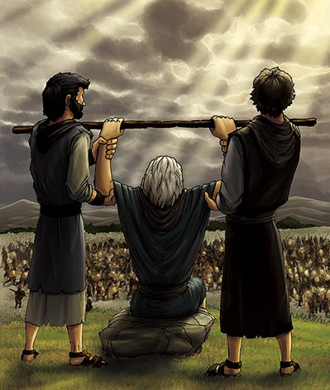
Exodus 17:8 Then came Amalek, and fought with Israel in Rephidim.
Exodus 17:9 And Moses said unto Joshua, Choose us out men, and go out, fight with Amalek: to morrow I will stand on the top of the hill with the rod of God in mine hand.
Exodus 17:10 So Joshua did as Moses had said to him, and fought with Amalek: and Moses, Aaron, and Hur went up to the top of the hill.
Exodus 17:11 And it came to pass, when Moses held up his hand, that Israel prevailed: and when he let down his hand, Amalek prevailed.
Exodus 17:12 But Moses' hands were heavy; and they took a stone, and put it under him, and he sat thereon; and Aaron and Hur stayed up his hands, the one on the one side, and the other on the other side; and his hands were steady until the going down of the sun.
Exodus 17:13 And Joshua discomfited Amalek and his people with the edge of the sword.
Exodus 17:14 And the LORD said unto Moses, Write this for a memorial in a book, and rehearse it in the ears of Joshua: for I will utterly put out the remembrance of Amalek from under heaven.
Exodus 17:15 And Moses built an altar, and called the name of it Jehovah-nissi:
Exodus 17:16 For he said, Because the LORD hath sworn that the LORD will have war with Amalek from generation to generation.
Our excursion through Exodus has been instructive especially when we realize that the Lord gave us this book using the Israelites as examples so that we don’t; “Lust after evil things as they also lusted”. (I Corinthians 10:6) Let’s just review some of what the Lord pointed out in His Word so far:
- So far, we have observed the need for a total “walk of faith” to pass through trials victoriously. Many of the Israelites, while not believing that God would deliver them as He said, instead fostered unbelief while allowing the “pull of Egypt” (A type of the world) to draw them. They are trading the eternal for the immediate.
- We have also observed the need for water. God instructs His people that there is the “living water”, that is eternally more important than the physical water for which they thirsted. Just like Jesus instructed the woman at the well she would never thirst again. Also in John chapter 7, at the feast of Tabernacles, Jesus stated the water He would give (The Holy Ghost) we will see: “out of his belly shall flow rivers of living water. (Speaking of the Holy Ghost who would come after Jesus had been glorified (On the cross)
- We saw the Israelites observing the first Passover, (foreshadowing Christ crucified), and participating in the unleavened bread for 7 days foreshadowing our sanctification; but it wasn’t until they were victorious in their first trial, passing through the Red Sea on dry ground, that they were given the song of the redeemed.
- We observed thirst in Marah, the people murmuring against Moses and God, none the less we saw God making the bitter waters sweet.
- We observed the need for bread in the wilderness and God raining manna in the land of sin. We also saw how that Manna typifies the Word, Jesus Christ, and the Holy Ghost.
- We saw the smiting of the Rock, that Rock is Christ. The water typified the Holy Ghost
- We observed the 3 “Rods” of Scripture typifying Christ’s three offices. But right away, after the water flows out of the Rock, the Amalekites attack Israel:
I. The War Begins
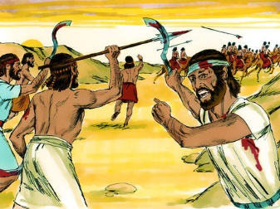
A. The Enemy
Exodus 17:8 Then came Amalek, and fought with Israel in Rephidim.
1. The enemy is the Amalekites - Amalek was the grandson of Esau
Genesis 36:12 And Timna was concubine to Eliphaz Esau's son; and she bare to Eliphaz Amalek: these were the sons of Adah Esau's wife.
2. Esau is a type of the “flesh” - despised the eternal for the immediate - very carnal
Hebrews 12:15 Looking diligently lest any man fail of the grace of God; lest any root of bitterness springing up trouble you, and thereby many be defiled;
Hebrews 12:16 Lest there be any fornicator, or profane person, as Esau, who for one morsel of meat sold his birthright.
3. Notice it was not Israel who attacked first, but Amalek. In type it is the same. It is the “flesh” that attacks first, is called the first nation, but is destined to perish forever.
Numbers 24:20 And when he looked on Amalek, he took up his parable, and said, Amalek was the first of the nations; but his latter end shall be that he perish for ever.
As Jesus told Nickodemis:
John 3:6 That which is born of the flesh is flesh; and that which is born of the Spirit is spirit.
Romans 8:13 For if ye live after the flesh, ye shall die: but if ye through the Spirit do mortify the deeds of the body, ye shall live.
4. The worthlessness of Amalek:
1 Samuel 15:1 Samuel also said unto Saul, The LORD sent me to anoint thee to be king over his people, over Israel: now therefore hearken thou unto the voice of the words of the LORD.
1 Samuel 15:2 Thus saith the LORD of hosts, I remember that which Amalek did to Israel, how he laid wait for him in the way, when he came up from Egypt.
1 Samuel 15:3 Now go and smite Amalek, and utterly destroy all that they have, and spare them not; but slay both man and woman, infant and suckling, ox and sheep, camel and ass.
1 Samuel 15:4 And Saul gathered the people together, and numbered them in Telaim, two hundred thousand footmen, and ten thousand men of Judah.
1 Samuel 15:5 And Saul came to a city of Amalek, and laid wait in the valley.
1 Samuel 15:6 And Saul said unto the Kenites, Go, depart, get you down from among the Amalekites, lest I destroy you with them: for ye shewed kindness to all the children of Israel, when they came up out of Egypt. So the Kenites departed from among the Amalekites.
1 Samuel 15:7 And Saul smote the Amalekites from Havilah until thou comest to Shur, that is over against Egypt.
1 Samuel 15:8 And he took Agag the king of the Amalekites alive, and utterly destroyed all the people with the edge of the sword.
1 Samuel 15:9 But Saul and the people spared Agag, and the best of the sheep, and of the oxen, and of the fatlings, and the lambs, and all that was good, and would not utterly destroy them: but every thing that was vile and refuse, that they destroyed utterly.
1 Samuel 15:10 Then came the word of the LORD unto Samuel, saying,
1 Samuel 15:11 It repenteth me that I have set up Saul to be king: for he is turned back from following me, and hath not performed my commandments. And it grieved Samuel; and he cried unto the LORD all night.
1 Samuel 15:12 And when Samuel rose early to meet Saul in the morning, it was told Samuel, saying, Saul came to Carmel, and, behold, he set him up a place, and is gone about, and passed on, and gone down to Gilgal.
1 Samuel 15:13 And Samuel came to Saul: and Saul said unto him, Blessed be thou of the LORD: I have performed the commandment of the LORD.
1 Samuel 15:14 And Samuel said, What meaneth then this bleating of the sheep in mine ears, and the lowing of the oxen which I hear?
1 Samuel 15:15 And Saul said, They have brought them from the Amalekites: for the people spared the best of the sheep and of the oxen, to sacrifice unto the LORD thy God; and the rest we have utterly destroyed.
1 Samuel 15:16 Then Samuel said unto Saul, Stay, and I will tell thee what the LORD hath said to me this night. And he said unto him, Say on.
1 Samuel 15:17 And Samuel said, When thou wast little in thine own sight, wast thou not made the head of the tribes of Israel, and the LORD anointed thee king over Israel?
1 Samuel 15:18 And the LORD sent thee on a journey, and said, Go and utterly destroy the sinners the Amalekites, and fight against them until they be consumed.
1 Samuel 15:19 Wherefore then didst thou not obey the voice of the LORD, but didst fly upon the spoil, and didst evil in the sight of the LORD?
1 Samuel 15:20 And Saul said unto Samuel, Yea, I have obeyed the voice of the LORD, and have gone the way which the LORD sent me, and have brought Agag the king of Amalek, and have utterly destroyed the Amalekites.
1 Samuel 15:21 But the people took of the spoil, sheep and oxen, the chief of the things which should have been utterly destroyed, to sacrifice unto the LORD thy God in Gilgal.
1 Samuel 15:22 And Samuel said, Hath the LORD as great delight in burnt offerings and sacrifices, as in obeying the voice of the LORD? Behold, to obey is better than sacrifice, and to hearken than the fat of rams.
1 Samuel 15:23 For rebellion is as the sin of witchcraft, and stubbornness is as iniquity and idolatry. Because thou hast rejected the word of the LORD, he hath also rejected thee from being king.
1 Samuel 15:24 And Saul said unto Samuel, I have sinned: for I have transgressed the commandment of the LORD, and thy words: because I feared the people, and obeyed their voice.
1 Samuel 15:25 Now therefore, I pray thee, pardon my sin, and turn again with me, that I may worship the LORD.
1 Samuel 15:26 And Samuel said unto Saul, I will not return with thee: for thou hast rejected the word of the LORD, and the LORD hath rejected thee from being king over Israel.
The flesh also is worthless, there is no good in it at all - It must be completely wiped out
Romans 7:18 For I know that in me (that is, in my flesh,) dwelleth no good thing: for to will is present with me; but how to perform that which is good I find not.
5. Amalek attacks first, but will perish for ever
Deuteronomy 25:17 Remember what Amalek did unto thee by the way, when ye were come forth out of Egypt;
Deuteronomy 25:18 How he met thee by the way, and smote the hindmost of thee, even all that were feeble behind thee, when thou wast faint and weary; and he feared not God.
Deuteronomy 25:19 Therefore it shall be, when the LORD thy God hath given thee rest from all thine enemies round about, in the land which the LORD thy God giveth thee for an inheritance to possess it, that thou shalt blot out the remembrance of Amalek from under heaven; thou shalt not forget it.
Obviously, God is not talking about Canaan land to which Joshua lead the people from the wilderness, but a time when Israel will be led by the King of Kings and the Lord of Lords, and Israel will not forget it. Isaiah saw this time Moses was writing about:
Isaiah 34:6 The sword of the LORD is filled with blood, it is made fat with fatness, and with the blood of lambs and goats, with the fat of the kidneys of rams: for the LORD hath a sacrifice in Bozrah, and a great slaughter in the land of Idumea.
6. Yes, Amalek attacks first and hard, but God’s “people who walk in His Law” - you will notice there has been no “Law” drawn up yet! it is as Christ said to Satan Christ’s own war that man shall “That man shall not live by bread alone, but by every word of God.” Luke 4:4
7. In our typology, the flesh will hit first and hard, and if we succumb to the flesh, we too shall perish, but God’s people can not only be triumphant, but have joy unspeakable. (I peter 1:8)
Galatians 5:16 This I say then, Walk in the Spirit, and ye shall not fulfil the lust of the flesh.
Galatians 5:17 For the flesh lusteth against the Spirit, and the Spirit against the flesh: and these are contrary the one to the other: so that ye cannot do the things that ye would.
Galatians 5:18 But if ye be led of the Spirit, ye are not under the law.
James 1:12 Blessed is the man that endureth temptation: for when he is tried, he shall receive the crown of life, which the Lord hath promised to them that love him.
James 1:13 Let no man say when he is tempted, I am tempted of God: for God cannot be tempted with evil, neither tempteth he any man:
James 1:14 But every man is tempted, when he is drawn away of his own lust, and enticed.
James 1:15 Then when lust hath conceived, it bringeth forth sin: and sin, when it is finished, bringeth forth death.
7. But Amalek is determined, and if not completely destroyed will attack again - harder
Now after the death of King Saul, a man came to King David with the news of Sau’s death. He claimed that he found Saul on top of mount Gilboa and that Saul had fallen on his sword. This man then said Saul begged him to finish him off, and this man told David that he did. David then asked him who he was:
II Samuel 1:8 And he said unto me, Who art thou? And I answered him, I am an Amalekite.
II Samuel 1:9 He said unto me again, Stand, I pray thee, upon me, and slay me: for anguish is come upon me, because my life is yet whole in me.
II Samuel 1:10 So I stood upon him, and slew him, because I was sure that he could not live after that he was fallen: and I took the crown that was upon his head, and the bracelet that was on his arm, and have brought them hither unto my lord.
II Samuel 1:11 Then David took hold on his clothes, and rent them; and likewise all the men that were with him:
II Samuel 1:12 And they mourned, and wept, and fasted until even, for Saul, and for Jonathan his son, and for the people of the LORD, and for the house of Israel; because they were fallen by the sword.
II Samuel 1:13 And David said unto the young man that told him, Whence art thou? And he answered, I am the son of a stranger, an Amalekite.
II Samuel 1:14 And David said unto him, How wast thou not afraid to stretch forth thine hand to destroy the LORD'S anointed?
II Samuel 1:15 And David called one of the young men, and said, Go near, and fall upon him. And he smote him that he died.
Esther 3:1 After these things did king Ahasuerus promote Haman the son of Hammedatha the Agagite, and advanced him, and set his seat above all the princes that were with him.
Esther 3:2 And all the king's servants, that were in the king's gate, bowed, and reverenced Haman: for the king had so commanded concerning him. But Mordecai bowed not, nor did him reverence.
Esther 3:3 Then the king's servants, which were in the king's gate, said unto Mordecai, Why transgresses thou the king's commandment?
Esther 3:4 Now it came to pass, when they spake daily unto him, and he hearkened not unto them, that they told Haman, to see whether Mordecai's matters would stand: for he had told them that he was a Jew.
Esther 3:5 And when Haman saw that Mordecai bowed not, nor did him reverence, then was Haman full of wrath.
Esther 3:6 And he thought scorn to lay hands on Mordecai alone; for they had shewed him the people of Mordecai: wherefore Haman sought to destroy all the Jews that were throughout the whole kingdom of Ahasuerus, even the people of Mordecai.
Esther 3:7 In the first month, that is, the month Nisan, in the twelfth year of king Ahasuerus, they cast Pur, that is, the lot, before Haman from day to day, and from month to month, to the twelfth month, that is, the month Adar.
Esther 3:8 And Haman said unto king Ahasuerus, There is a certain people scattered abroad and dispersed among the people in all the provinces of thy kingdom; and their laws are diverse from all people; neither keep they the king's laws: therefore it is not for the king's profit to suffer them.
Esther 3:9 If it please the king, let it be written that they may be destroyed: and I will pay ten thousand talents of silver to the hands of those that have the charge of the business, to bring it into the king's treasuries.
Esther 3:10 And the king took his ring from his hand, and gave it unto Haman the son of Hammedatha the Agagite, the Jews' enemy.
You see that Satan used Amalek to make fools of Israel since he was not defeated totally, and Amalek would like nothing more than to annihilate Israel.
B. God has men chosen to fight
Exodus 17:9 And Moses said unto Joshua, Choose us out men
1. The Lord had fought Israel’s battles before
Exodus 14:14 The LORD shall fight for you, and ye shall hold your peace.
2. God brought these people through their first trials but now it is armor and fighting time
3. We today must also fight when attacked
I Timothy 6:9 But they that will be rich fall into temptation and a snare, and into many foolish and hurtful lusts, which drown men in destruction and perdition.
I Timothy 6:10 For the love of money is the root of all evil: which while some coveted after, they have erred from the faith, and pierced themselves through with many sorrows.
I Timothy 6:11 But thou, O man of God, flee these things; and follow after righteousness, godliness, faith, love, patience, meekness.
I Timothy 6:12 Fight the good fight of faith, lay hold on eternal life, whereunto thou art also called, and hast professed a good profession before many witnesses.
4. Paul said to Timothy:
II Timothy 4:7 I have fought a good fight, I have finished my course, I have kept the faith:
II Timothy 4:8 Henceforth there is laid up for me a crown of righteousness, which the Lord, the righteous judge, shall give me at that day: and not to me only, but unto all them also that love his appearing.
I Corinthians 9:24 Know ye not that they which run in a race run all, but one receiveth the prize? So run, that ye may obtain.
I Corinthians 9:25 And every man that striveth for the mastery is temperate in all things. Now they do it to obtain a corruptible crown; but we an incorruptible.
I Corinthians 9:26 I therefore so run, not as uncertainly; so fight I, not as one that beateth the air:
I Corinthians 9:27 But I keep under my body, and bring it into subjection: lest that by any means, when I have preached to others, I myself should be a castaway.
Jude 18 How that they told you there should be mockers in the last time, who should walk after their own ungodly lusts.
Jude 19 These be they who separate themselves, sensual, having not the Spirit.
Jude 20 But ye, beloved, building up yourselves on your most holy faith, praying in the Holy Ghost,
Jude 21 Keep yourselves in the love of God, looking for the mercy of our Lord Jesus Christ unto eternal life.
Jude 22 And of some have compassion, making a difference:
Jude 23 And others save with fear, pulling them out of the fire; hating even the garment spotted by the flesh.
II. Two Battlefronts - One on the top of the hill, one down on the ground
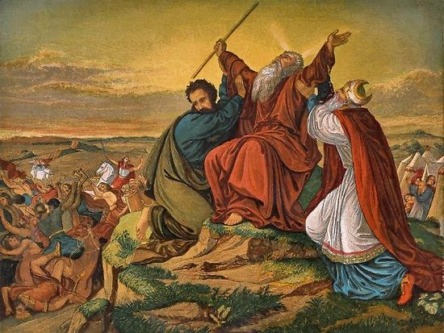
A. Command Post is on top of the hill
1. Modern day war is commanded not from the front line, but from a higher vision point
2. Here, it is from the hill that the orders are issued, where the vantage point is better
3. From the hill the right position is given or the retreat is announced
I Corinthians 10:13 There hath no temptation taken you but such as is common to man: but God is faithful, who will not suffer you to be tempted above that ye are able; but will with the temptation also make a way to escape, that ye may be able to bear it.
4. The Psalmist must have seen this:
Psalm 121:1 I will lift up mine eyes unto the hills, from whence cometh my help.
Psalm 121:2 My help cometh from the LORD, which made heaven and earth.
5. Up on the hill we have again the three offices of Christ
a. Prophet (represented by Moses),
b. Priest (represented by Aaron)
c. King (represented by Hur of Judah, Exodus 31:2).
6. The Battle is fought first in the heavens by the Command of our High Priest
Hebrews 7:19 For the law made nothing perfect, but the bringing in of a better hope did; by the which we draw nigh unto God.
Hebrews 7:22 By so much was Jesus made a surety of a better testament.
Hebrews 7:23 And they truly were many priests, because they were not suffered to continue by reason of death:
Hebrews 7:24 But this man, because he continueth ever, hath an unchangeable priesthood.
Hebrews 7:25 Wherefore he is able also to save them to the uttermost that come unto God by him, seeing he ever liveth to make intercession for them.
Hebrews 7:26 For such an high priest became us, who is holy, harmless, undefiled, separate from sinners, and made higher than the heavens;
7. But we battle here on earth with the armor of God
Ephesians 6:12 For we wrestle not against flesh and blood, but against principalities, against powers, against the rulers of the darkness of this world, against spiritual wickedness in high places.
Ephesians 6:13 Wherefore take unto you the whole armour of God, that ye may be able to withstand in the evil day, and having done all, to stand.
Ephesians 6:14 Stand therefore, having your loins girt about with truth, and having on the breastplate of righteousness;
Ephesians 6:15 And your feet shod with the preparation of the gospel of peace;
Ephesians 6:16 Above all, taking the shield of faith, wherewith ye shall be able to quench all the fiery darts of the wicked.
Ephesians 6:17 And take the helmet of salvation, and the sword of the Spirit, which is the word of God:
Ephesians 6:18 Praying always with all prayer and supplication in the Spirit, and watching thereunto with all perseverance and supplication for all saints;
B. War with Amalek – Type of the flesh all through Scripture. Why?
God’s people experience a battle between the flesh and the Spirit (Galatians 5:27, Romans 7). God’s people decide their own fate in this battle. If we give into the “pull of the world” like the Israelites did, murmuring ensues, and if no repentance is seen, departing from God happens. Entrance into the Rest of the Lord will be denied
Hebrews 3:9 When your fathers tempted me, proved me, and saw my works forty years.
Hebrews 3:10 Wherefore I was grieved with that generation, and said, They do alway err in their heart; and they have not known my ways.
Hebrews 3:11 So I sware in my wrath, They shall not enter into my rest.)
Hebrews 3:12 Take heed, brethren, lest there be in any of you an evil heart of unbelief, in departing from the living God.
Hebrews 3:13 But exhort one another daily, while it is called To day; lest any of you be hardened through the deceitfulness of sin.
Hebrews 3:14 For we are made partakers of Christ, if we hold the beginning of our confidence stedfast unto the end;
Hebrews 3:15 While it is said, To day if ye will hear his voice, harden not your hearts, as in the provocation.
Hebrews 3:16 For some, when they had heard, did provoke: howbeit not all that came out of Egypt by Moses.
Hebrews 3:17 But with whom was he grieved forty years? was it not with them that had sinned, whose carcases fell in the wilderness?
Hebrews 3:18 And to whom sware he that they should not enter into his rest, but to them that believed not?
1 Peter 2:9 But ye are a chosen generation, a royal priesthood, an holy nation, a peculiar people; that ye should shew forth the praises of him who hath called you out of darkness into his marvellous light:
1 Peter 2:10 Which in time past were not a people, but are now the people of God: which had not obtained mercy, but now have obtained mercy.
1 Peter 2:11 Dearly beloved, I beseech you as strangers and pilgrims, abstain from fleshly lusts, which war against the soul;
1 Peter 2:12 Having your conversation honest among the Gentiles: that, whereas they speak against you as evildoers, they may by your good works, which they shall behold, glorify God in the day of visitation.

War with Amalek - The Lord My Banner, Jehovah Nissi
In the Wilderness | At the Cross | On Route at the 2nd Advent
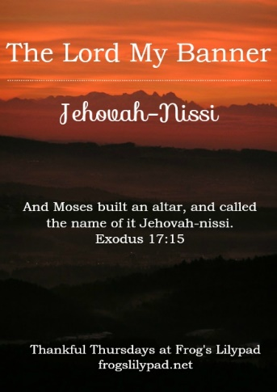 | 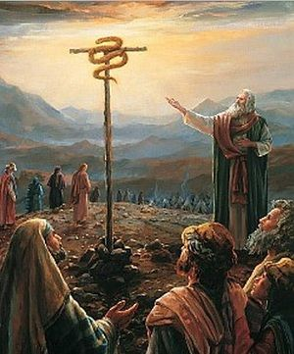 | 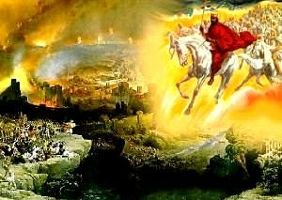
Exodus 17:14 And the LORD said unto Moses, Write this for a memorial in a book, and rehearse it in the ears of Joshua: for I will utterly put out the remembrance of Amalek from under heaven.  Exodus 17:15 And Moses built an altar, and called the name of it Jehovah-nissi:  Exodus 17:16 For he said, Because the LORD hath sworn that the LORD will have war with Amalek from generation to generation. | John 12:32 And I, if I be lifted up from the earth, will draw all men unto me. | Deuteronomy 25:17 Remember what Amalek did unto thee by the way, when ye were come forth out of Egypt;  Deuteronomy 25:18 How he met thee by the way, and smote the hindmost of thee, even all that were feeble behind thee, when thou wast faint and weary; and he feared not God.  Deuteronomy 25:19 Therefore it shall be, when the LORD thy God hath given thee rest from all thine enemies round about, in the land which the LORD thy God giveth thee for an inheritance to possess it, that thou shalt blot out the remembrance of Amalek from under heaven; thou shalt not forget it.  Isaiah 34:4 And all the host of heaven shall be dissolved, and the heavens shall be rolled together as a scroll: and all their host shall fall down, as the leaf falleth off from the vine, and as a falling fig from the fig tree.  Isaiah 34:5 For my sword shall be bathed in heaven: behold, it shall come down upon Idumea, and upon the people of my curse, to judgment.  Isaiah 34:6 The sword of the LORD is filled with blood, it is made fat with fatness, and with the blood of lambs and goats, with the fat of the kidneys of rams: for the LORD hath a sacrifice in Bozrah, and a great slaughter in the land of Idumea.

