The Second Advent of God’s Only Begotten Son
Psalm 2:1 Why do the heathen rage, and the people imagine a vain thing?
Psalm 2:2 The kings of the earth set themselves, and the rulers take counsel together, against the LORD, and against his anointed, saying,
Psalm 2:3 Let us break their bands asunder, and cast away their cords from us.
Psalm 2:4 He that sitteth in the heavens shall laugh: the Lord shall have them in derision.
Psalm 2:5 Then shall he speak unto them in his wrath, and vex them in his sore displeasure.
Psalm 2:6 Yet have I set my king upon my holy hill of Zion.
Psalm 2:7 I will declare the decree: the LORD hath said unto me, Thou art my Son; this day have I begotten thee.
Psalm 2:8 Ask of me, and I shall give thee the heathen for thine inheritance, and the uttermost parts of the earth for thy possession.
Genesis 11:1 And the whole earth was of one language, and of one speech.
Genesis 11:2 And it came to pass, as they journeyed from the east, that they found a plain in the land of Shinar; and they dwelt there.
Genesis 11:3 And they said one to another, Go to, let us make brick, and burn them throughly. And they had brick for stone, and slime had they for morter.
Genesis 11:4 And they said, Go to, let us build us a city and a tower, whose top may reach unto heaven; and let us make us a name, lest we be scattered abroad upon the face of the whole earth.
Genesis 11:5 And the LORD came down to see the city and the tower, which the children of men builded.
Genesis 11:6 And the LORD said, Behold, the people is one, and they have all one language; and this they begin to do: and now nothing will be restrained from them, which they have imagined to do.
Genesis 11:7 Go to, let us go down, and there confound their language, that they may not understand one another’s speech.
Genesis 11:8 So the LORD scattered them abroad from thence upon the face of all the earth: and they left off to build the city.
Genesis 11:9 Therefore is the name of it called Babel; because the LORD did there confound the language of all the earth: and from thence did the LORD scatter them abroad upon the face of all the earth.

Revelation 19:11 And I saw heaven opened, and behold a white horse; and he that sat upon him was called Faithful and True, and in righteousness he doth judge and make war.
Revelation 19:12 His eyes were as a flame of fire, and on his head were many crowns; and he had a name written, that no man knew, but he himself.
Revelation 19:13 And he was clothed with a vesture dipped in blood: and his name is called The Word of God.
Revelation 19:14 And the armies which were in heaven followed him upon white horses, clothed in fine linen, white and clean.
Revelation 19:15 And out of his mouth goeth a sharp sword, that with it he should smite the nations: and he shall rule them with a rod of iron: and he treadeth the winepress of the fierceness and wrath of Almighty God.
Revelation 19:16 And he hath on his vesture and on his thigh a name written, KING OF KINGS, AND LORD OF LORDS.

Isaiah 63:1 Who is this that cometh from Edom, with dyed garments from Bozrah? this that is glorious in his apparel, travelling in the greatness of his strength? I that speak in righteousness, mighty to save.
Isaiah 63:2 Wherefore art thou red in thine apparel, and thy garments like him that treadeth in the winefat?
Isaiah 63:3 I have trodden the winepress alone; and of the people there was none with me:

The Second Advent of God’s Only Begotten Son

The Setting In Heaven Just Before The Second Advent

Revelation 19:1 And after these things I heard a great voice of much people in heaven, saying, Alleluia; Salvation, and glory, and honour, and power, unto the Lord our God:
Revelation 19:2 For true and righteous are his judgments: for he hath judged the great whore, which did corrupt the earth with her fornication, and hath avenged the blood of his servants at her hand.
Revelation 19:3 And again they said, Alleluia. And her smoke rose up for ever and ever.
Revelation 19:4 And the four and twenty elders and the four beasts fell down and worshipped God that sat on the throne, saying, Amen; Alleluia.
Revelation 19:5 And a voice came out of the throne, saying, Praise our God, all ye his servants,
Revelation 19:6 And I heard as it were the voice of a great multitude, and as the voice of many waters, and as the voice of mighty thunderings, saying, Alleluia: for the Lord God omnipotent reigneth.
Revelation 19:7 Let us be glad and rejoice, and give honour to him: for the marriage of the Lamb is come, and his wife hath made herself ready.
Revelation 19:8 And to her was granted that she should be arrayed in fine linen, clean and white: for the fine linen is the righteousness of saints.
Revelation 19:9 And he saith unto me, Write, Blessed are they which are called unto the marriage supper of the Lamb. And he saith unto me, These are the true sayings of God.
Revelation 19:10 And I fell at his feet to worship him. And he said unto me, See thou do it not: I am thy fellowservant, and of thy brethren that have the testimony of Jesus: worship God: for the testimony of Jesus is the spirit of prophecy.

Then The Door of Heaven is Opened and The King is Revealed

Revelation 19:11 And I saw heaven opened, and behold a white horse; and he that sat upon him was called Faithful and True, and in righteousness he doth judge and make war.
Revelation 19:12 His eyes were as a flame of fire, and on his head were many crowns; and he had a name written, that no man knew, but he himself.
Revelation 19:13 And he was clothed with a vesture dipped in blood: and his name is called The Word of God.
Revelation 19:14 And the armies which were in heaven followed him upon white horses, clothed in fine linen, white and clean.
Revelation 19:15 And out of his mouth goeth a sharp sword, that with it he should smite the nations: and he shall rule them with a rod of iron: and he treadeth the winepress of the fierceness and wrath of Almighty God.
Revelation 19:16 And he hath on his vesture and on his thigh a name written, KING OF KINGS, AND LORD OF LORDS.

An Angel’s Call to the Supper of the Great God

Revelation 19:17 And I saw an angel standing in the sun; and he cried with a loud voice, saying to all the fowls that fly in the midst of heaven, Come and gather yourselves together unto the supper of the great God;
Revelation 19:18 That ye may eat the flesh of kings, and the flesh of captains, and the flesh of mighty men, and the flesh of horses, and of them that sit on them, and the flesh of all men, both free and bond, both small and great.
The kings of the earth and the rulers take counsel together, against the LORD, and His Anointed

Revelation 19:19 And I saw the beast, and the kings of the earth, and their armies, gathered together to make war against him that sat on the horse, and against his army.

The Antichrist and the False Prophet Cast into the Lake of Fire

Revelation 19:20 And the beast was taken, and with him the false prophet that wrought miracles before him, with which he deceived them that had received the mark of the beast, and them that worshipped his image. These both were cast alive into a lake of fire burning with brimstone.

The King of Kings Slays the Antichrist’s Armies with the Sword that Proceeds from His Mouth

Revelation 19:21 And the remnant were slain with the sword of him that sat upon the horse, which sword proceeded out of his mouth: and all the fowls were filled with their flesh.
Revelation 20:1 And I saw an angel come down from heaven, having the key of the bottomless pit and a great chain in his hand.

Satan is chained for the Thousand Year Kingdom

Revelation 20:2 And he laid hold on the dragon, that old serpent, which is the Devil, and Satan, and bound him a thousand years,
Revelation 20: 3 And cast him into the bottomless pit, and shut him up, and set a seal upon him, that he should deceive the nations no more, till the thousand years should be fulfilled: and after that he must be loosed a little season.

An Entrance to the Kingdom for the Tribulation Saints

Revelation 20:4 And I saw thrones, and they sat upon them, and judgment was given unto them: and I saw the souls of them that were beheaded for the witness of Jesus, and for the word of God, and which had not worshipped the beast, neither his image, neither had received his mark upon their foreheads, or in their hands; and they lived and reigned with Christ a thousand years.
Revelation 20:5 But the rest of the dead lived not again until the thousand years were finished. This is the first resurrection.
Revelation 20:6 Blessed and holy is he that hath part in the first resurrection: on such the second death hath no power, but they shall be priests of God and of Christ, and shall reign with him a thousand years.

The Final War and Satan’s Doom

Revelation 20:7 And when the thousand years are expired, Satan shall be loosed out of his prison,
Revelation 20:8 And shall go out to deceive the nations which are in the four quarters of the earth, Gog and Magog, to gather them together to battle: the number of whom is as the sand of the sea.
Revelation 20:9 And they went up on the breadth of the earth, and compassed the camp of the saints about, and the beloved city: and fire came down from God out of heaven, and devoured them.
Revelation 20:10 And the devil that deceived them was cast into the lake of fire and brimstone, where the beast and the false prophet are, and shall be tormented day and night for ever and ever.

II. The Second Advent is also the Context of Psalm 2:

References of Psalm 2 in Revelation
Reference In Psalm 2 | Fulfilled In Revelation
1 ¶ Why do the heathen rage, and the people imagine a vain thing? 2 The kings of the earth set themselves, and the rulers take counsel together, against the LORD, and against his anointed, saying, | 16:14 For they are the spirits of devils, working miracles, which go forth unto the kings of the earth and of the whole world, to gather them to the battle of that great day of God Almighty.
3 Let us break their bands asunder, and cast away their cords from us. 4 He that sitteth in the heavens shall laugh: the Lord shall have them in derision. 5 Then shall he speak unto them in his wrath, and vex them in his sore displeasure. | 19:11 And I saw heaven opened, and behold a white horse; and he that sat upon him was called Faithful and True, and in righteousness he doth judge and make war..15 And out of his mouth goeth a sharp sword, that with it he should smite the nations: and he shall rule them with a rod of iron: and he treadeth the winepress of the fierceness and wrath of Almighty God.
7 I will declare the decree: the LORD hath said unto me, Thou art my Son; this day have I begotten thee. | 1:5 And from Jesus Christ, who is the faithful witness, and the first begotten of the dead, and the prince of the kings of the earth. Unto him that loved us, and washed us from our sins in his own blood,
8 Ask of me, and I shall give thee the heathen for thine inheritance, and the uttermost parts of the earth for thy possession. | 21:24 And the nations of them which are saved shall walk in the light of it: and the kings of the earth do bring their glory and honour into it.
9 Thou shalt break them with a rod of iron; thou shalt dash them in pieces like a potter’s vessel. 10 Be wise now therefore, O ye kings: be instructed, ye judges of the earth. | 19:15 And out of his mouth goeth a sharp sword, that with it he should smite the nations: and he shall rule them with a rod of iron: and he treadeth the winepress of the fierceness and wrath of Almighty God.
11 Serve the LORD with fear, and rejoice with trembling. 12 Kiss the Son, lest he be angry, and ye perish from the way, when his wrath is kindled but a little. Blessed are all they that put their trust in him. | 22:2 In the midst of the street of it, and on either side of the river, was there the tree of life, which bare twelve manner of fruits, and yielded her fruit every month: and the leaves of the tree were for the healing of the nations.  3 And there shall be no more curse: but the throne of God and of the Lamb shall be in it; and his servants shall serve him:

Psalm 2:9 Thou shalt break them with a rod of iron; thou shalt dash them in pieces like a potter’s vessel.
Psalm 2:10 Be wise now therefore, O ye kings: be instructed, ye judges of the earth.
Psalm 2:11 Serve the LORD with fear, and rejoice with trembling.
Psalm 2:12 Kiss the Son, lest he be angry, and ye perish from the way, when his wrath is kindled but a little. Blessed are all they that put their trust in him.
III. Christ’s Second Advent is in Two Stages: One Private and One Public

- This Should Be No Surprise, It is the Same with Christ’s First Coming and Ascension:

The Two Part First Advent Of Jesus Christ
First Stage - Private | Believers like (Anna, Simeon, Wise Men, etc. )
Second Stage - Public | Public Baptism, Ministry, and Public Death
The Two Part Ascension
First Stage - Private | Seen only of Mary then ascends to the Father
Second Stage - Public | Seen of the twelve, and later 500 people
The Two Part Second Advent
First Stage - Private | Only the Church Sees Him
Second Stage - Public | The Whole World Affected

- Contrast Between the Rapture and the Second Advent:

Contrasting the Rapture and the Second Advent
Rapture | Second Advent
Christ Comes For His Saints | Christ Coming With His Saints
Saints are Caught in the Air with Christ | Saints Return With Christ
Brings Hope and Comfort to Earth | Brings Fear and Judgment to Earth
Is a New Testament Mystery | Is the Subject of Many Old Testament Prophecies
Consists of no Signs only Promise | Many Signs Precedes this Event
Promise Only to the Church | Promise Primarily to Israel, but also the Nations
Church is Taken into Christ’s Presence For Ever | Israel Ushered into the Kingdom
1st Opening of Heaven – John Ascends (church) | 2nd Opening of Heaven – Christ & Saints Descend
Two Separate Events That Happen at Separate Times – 7 Years apart

- A New Testament Mystery, but Many types in the Old Testament:

Types of the Rapture Demonstrate at what point the Rapture Occurs
Enoch is translated into heaven before the flood  (A Type of the Tribulation) | Genesis 5:23-24; Flood Chapter 6
Lot is rescued out of Sodom before the fire fell  (A Type of the Tribulation) | Genesis 19:15; Fire Fell 19:23-24
Joseph takes a Gentile Bride Before the famine  (A Type of the Tribulation) | Joseph’s Egyptian Bride, Asenath – Genesis 41:45;  Famine started Genesis 41:54. (But there was bread in Egypt.
Moses takes a Gentile Bride Before the Plagues  (A Type of the Tribulation) | Moses took his Midianite bride, Zaporah - Exodus 2:21-22; Plagues of Egypt begin in Chapter 7.
Each Event Happened Before The “Type” of the Tribulation

IV. After the Rapture, God Resumes His Dealings with Israel – (Ending Judgment and To Bring them Back to God)

- When we read Joel 2, Matthew 24, and Revelation 6-19, We find scary things:
- It’s like all the lights are turned off. (Sun black as sackcloth, Moon turned to blood, etc.)
- But toward the end of the seven years, people will not need tactical flashlights, because the glory of Christ Jesus will be seen above the mountains.

Joel 2:1 Blow ye the trumpet in Zion, and sound an alarm in my holy mountain: let all the inhabitants of the land tremble: for the day of the LORD cometh, for it is nigh at hand;
Joel 2:2 A day of darkness and of gloominess, a day of clouds and of thick darkness, as the morning spread upon the mountains: a great people and a strong; there hath not been ever the like, neither shall be any more after it, even to the years of many generations.

- We have a very graphic word picture of happenings in heaven.

Revelation 14:14 And I looked, and behold a white cloud, and upon the cloud one sat like unto the Son of man, having on his head a golden crown, and in his hand a sharp sickle.
Revelation 14:15 And another angel came out of the temple, crying with a loud voice to him that sat on the cloud, Thrust in thy sickle, and reap: for the time is come for thee to reap; for the harvest of the earth is ripe.
Revelation 14:16 And he that sat on the cloud thrust in his sickle on the earth; and the earth was reaped.
Revelation 14:17 And another angel came out of the temple which is in heaven, he also having a sharp sickle.
Revelation 14:18 And another angel came out from the altar, which had power over fire; and cried with a loud cry to him that had the sharp sickle, saying, Thrust in thy sharp sickle, and gather the clusters of the vine of the earth; for her grapes are fully ripe.
Revelation 14:19 And the angel thrust in his sickle into the earth, and gathered the vine of the earth, and cast it into the great winepress of the wrath of God.
Revelation 14:20 And the winepress was trodden without the city, and blood came out of the winepress, even unto the horse bridles, by the space of a thousand and six hundred furlongs.

- We have Isaiah to help us out a bit in the same connection:

Isaiah 24:21 And it shall come to pass in that day, that the LORD shall punish the host of the high ones that are on high, and the kings of the earth upon the earth.
Isaiah 24:22 And they shall be gathered together, as prisoners are gathered in the pit, and shall be shut up in the prison, and after many days shall they be visited.
Isaiah 24:23 Then the moon shall be confounded, and the sun ashamed, when the LORD of hosts shall reign in mount Zion, and in Jerusalem, and before his ancients gloriously.

- What first happens in heaven is then played out on earth.
- As an example: Remember when Daniel had fasted for 3 weeks without answer while the battle with Persia was fought in heaven? (A Change of Empires first played out in heaven.)

Daniel 10:11 And he said unto me, O Daniel, a man greatly beloved, understand the words that I speak unto thee, and stand upright: for unto thee am I now sent. And when he had spoken this word unto me, I stood trembling.
Daniel 10:12 Then said he unto me, Fear not, Daniel: for from the first day that thou didst set thine heart to understand, and to chasten thyself before thy God, thy words were heard, and I am come for thy words.
Daniel 10:13 But the prince of the kingdom of Persia withstood me one and twenty days: but, lo, Michael, one of the chief princes, came to help me; and I remained there with the kings of Persia.
Daniel 10:14 Now I am come to make thee understand what shall befall thy people in the latter days:

V. What armies follow Christ to the earth? Based on their raiment, we can identify two groups:

Revelation 19:14 And the armies which were in heaven followed him upon white horses, clothed in fine linen, white and clean.

- Tribulation martyred saints undoubtedly one army (Those who slain for their testimony)

Revelation 6:9 And when he had opened the fifth seal, I saw under the altar the souls of them that were slain for the word of God, and for the testimony which they held:
Revelation 6:10 And they cried with a loud voice, saying, How long, O Lord, holy and true, dost thou not judge and avenge our blood on them that dwell on the earth?
Revelation 6:11 And white robes were given unto every one of them; and it was said unto them, that they should rest yet for a little season, until their fellowservants also and their brethren, that should be killed as they were, should be fulfilled.

- Tribulation saints also: (Those who refused the mark of the beast – Saved during the Tribulation)

Revelation 7:13 And one of the elders answered, saying unto me, What are these which are arrayed in white robes? and whence came they?
Revelation 7:14 And I said unto him, Sir, thou knowest. And he said to me, These are they which came out of great tribulation, and have washed their robes, and made them white in the blood of the Lamb.
Revelation 7:15 Therefore are they before the throne of God, and serve him day and night in his temple: and he that sitteth on the throne shall dwell among them.

- The Raptured church – Now the wife – Is another army

Revelation 19:7 Let us be glad and rejoice, and give honour to him: for the marriage of the Lamb is come, and his wife hath made herself ready.
Revelation 19:8 And to her was granted that she should be arrayed in fine linen, clean and white: for the fine linen is the righteousness of saints.
Revelation 19:9 And he saith unto me, Write, Blessed are they which are called unto the marriage supper of the Lamb. And he saith unto me, These are the true sayings of God.

VI. God will gather the Nations all in one place, so He can destroy them all at once: (As in Psalm 2)

Zephaniah 3:8 Therefore wait ye upon me, saith the LORD, until the day that I rise up to the prey: for my determination is to gather the nations, that I may assemble the kingdoms, to pour upon them mine indignation, even all my fierce anger: for all the earth shall be devoured with the fire of my jealousy.
Zephaniah 3:9 For then will I turn to the people a pure language, that they may all call upon the name of the LORD, to serve him with one consent.

VII. How will this indignation be waged?

- It is first fought in heaven:

Revelation 14:14 And I looked, and behold a white cloud, and upon the cloud one sat like unto the Son of man, having on his head a golden crown, and in his hand a sharp sickle.
Revelation 14:15 And another angel came out of the temple, crying with a loud voice to him that sat on the cloud, Thrust in thy sickle, and reap: for the time is come for thee to reap; for the harvest of the earth is ripe.
Revelation 14:16 And he that sat on the cloud thrust in his sickle on the earth; and the earth was reaped.
Revelation 14:17 And another angel came out of the temple which is in heaven, he also having a sharp sickle.
Revelation 14:18 And another angel came out from the altar, which had power over fire; and cried with a loud cry to him that had the sharp sickle, saying, Thrust in thy sharp sickle, and gather the clusters of the vine of the earth; for her grapes are fully ripe.
Revelation 14:19 And the angel thrust in his sickle into the earth, and gathered the vine of the earth, and cast it into the great winepress of the wrath of God.
Revelation 14:20 And the winepress was trodden without the city, and blood came out of the winepress, even unto the horse bridles, by the space of a thousand and six hundred furlongs.

- Then it plays out on earth – Singlehandedly by Christ and His Sword

Revelation 19:11 And I saw heaven opened, and behold a white horse; and he that sat upon him was called Faithful and True, and in righteousness he doth judge and make war.
Revelation 19:12 His eyes were as a flame of fire, and on his head were many crowns; and he had a name written, that no man knew, but he himself.
Revelation 19:13 And he was clothed with a vesture dipped in blood: and his name is called The Word of God.
Revelation 19:14 And the armies which were in heaven followed him upon white horses, clothed in fine linen, white and clean.
Revelation 19:15 And out of his mouth goeth a sharp sword, that with it he should smite the nations: and he shall rule them with a rod of iron: and he treadeth the winepress of the fierceness and wrath of Almighty God.
Revelation 19:16 And he hath on his vesture and on his thigh a name written, KING OF KINGS, AND LORD OF LORDS.
Revelation 19:17 And I saw an angel standing in the sun; and he cried with a loud voice, saying to all the fowls that fly in the midst of heaven, Come and gather yourselves together unto the supper of the great God;
Revelation 19:18 That ye may eat the flesh of kings, and the flesh of captains, and the flesh of mighty men, and the flesh of horses, and of them that sit on them, and the flesh of all men, both free and bond, both small and great.
Revelation 19:19 And I saw the beast, and the kings of the earth, and their armies, gathered together to make war against him that sat on the horse, and against his army.
Revelation 19:20 And the beast was taken, and with him the false prophet that wrought miracles before him, with which he deceived them that had received the mark of the beast, and them that worshipped his image. These both were cast alive into a lake of fire burning with brimstone.
Revelation 19:21 And the remnant were slain with the sword of him that sat upon the horse, which sword proceeded out of his mouth: and all the fowls were filled with their flesh.

VIII. What is the Path of the King of Kings at His Second Advent?

- While Moses was comforting the people of Israel he was also prophesying about the 2nd Advent:

Deuteronomy 33:1 And this is the blessing, wherewith Moses the man of God blessed the children of Israel before his death.
Deuteronomy 33:2 And he said, The LORD came from Sinai, and rose up from Seir unto them; he shined forth from mount Paran, and he came with ten thousands of saints: from his right hand went a fiery law for them.
Deuteronomy 33:3 Yea, he loved the people; all his saints are in thy hand: and they sat down at thy feet; every one shall receive of thy words. (See Also Psalm 68)

- Isaiah chimes in concerning the same Dead Sea Region:

Isaiah 34:1 Come near, ye nations, to hear; and hearken, ye people: let the earth hear, and all that is therein; the world, and all things that come forth of it.
Isaiah 34:2 For the indignation of the LORD is upon all nations, and his fury upon all their armies: he hath utterly destroyed them, he hath delivered them to the slaughter.
Isaiah 34:3 Their slain also shall be cast out, and their stink shall come up out of their carcases, and the mountains shall be melted with their blood.
Isaiah 34:4 And all the host of heaven shall be dissolved, and the heavens shall be rolled together as a scroll: and all their host shall fall down, as the leaf falleth off from the vine, and as a falling fig from the fig tree.
Isaiah 34:5 For my sword shall be bathed in heaven: behold, it shall come down upon Idumea, and upon the people of my curse, to judgment.
Isaiah 34:6 The sword of the LORD is filled with blood, it is made fat with fatness, and with the blood of lambs and goats, with the fat of the kidneys of rams: for the LORD hath a sacrifice in Bozrah, and a great slaughter in the land of Idumea.
Isaiah 34:7 And the unicorns shall come down with them, and the bullocks with the bulls; and their land shall be soaked with blood, and their dust made fat with fatness.
Isaiah 34:8 For it is the day of the LORD’S vengeance, and the year of recompences for the controversy of Zion.
Isaiah 34:9 And the streams thereof shall be turned into pitch, and the dust thereof into brimstone, and the land thereof shall become burning pitch.
Isaiah 34:10 It shall not be quenched night nor day; the smoke thereof shall go up for ever: from generation to generation it shall lie waste; none shall pass through it for ever and ever.

- The Again Isaiah prophesied concerning the Second Advent that Christ would come from Edom (modern-day Jordan) and Bozrah (Then Edom’s Capital on the day of vengeance.(Revelation 19:13)

Isaiah 63:1 Who is this that cometh from Edom, with dyed garments from Bozrah? this that is glorious in his apparel, travelling in the greatness of his strength? I that speak in righteousness, mighty to save.
Isaiah 63:2 Wherefore art thou red in thine apparel, and thy garments like him that treadeth in the winefat?
Isaiah 63:3 I have trodden the winepress alone; and of the people there was none with me: for I will tread them in mine anger, and trample them in my fury; and their blood shall be sprinkled upon my garments, and I will stain all my raiment.
Isaiah 63:4 For the day of vengeance is in mine heart, and the year of my redeemed is come.
Isaiah 63:5 And I looked, and there was none to help; and I wondered that there was none to uphold: therefore mine own arm brought salvation unto me; and my fury, it upheld me.

IX. After the seventh vial pours in heaven, there is a great earthquake on earth:

Revelation16:16 And he gathered them together into a place called in the Hebrew tongue Armageddon.
Revelation16:17 And the seventh angel poured out his vial into the air; and there came a great voice out of the temple of heaven, from the throne, saying, It is done.
Revelation16:18 And there were voices, and thunders, and lightnings; and there was a great earthquake, such as was not since men were upon the earth, so mighty an earthquake, and so great.
Revelation16:19 And the great city was divided into three parts, and the cities of the nations fell: and great Babylon came in remembrance before God, to give unto her the cup of the wine of the fierceness of his wrath.

Zechariah 14:1 Behold, the day of the LORD cometh, and thy spoil shall be divided in the midst of thee.
Zechariah 14:2 For I will gather all nations against Jerusalem to battle; and the city shall be taken, and the houses rifled, and the women ravished; and half of the city shall go forth into captivity, and the residue of the people shall not be cut off from the city.
Zechariah 14:3 Then shall the LORD go forth, and fight against those nations, as when he fought in the day of battle.
Zechariah 14:4 And his feet shall stand in that day upon the mount of Olives, which is before Jerusalem on the east, and the mount of Olives shall cleave in the midst thereof toward the east and toward the west, and there shall be a very great valley; and half of the mountain shall remove toward the north, and half of it toward the south.
Zechariah 14:5 And ye shall flee to the valley of the mountains; for the valley of the mountains shall reach unto Azal: yea, ye shall flee, like as ye fled from before the earthquake in the days of Uzziah king of Judah: and the LORD my God shall come, and all the saints with thee.
Zechariah 14:6 And it shall come to pass in that day, that the light shall not be clear, nor dark:
7 But it shall be one day which shall be known to the LORD, not day, nor night: but it shall come to pass, that at evening time it shall be light.
Zechariah 14:8 And it shall be in that day, that living waters shall go out from Jerusalem; half of them toward the former sea, and half of them toward the hinder sea: in summer and in winter shall it be.
Zechariah 14:9 And the LORD shall be king over all the earth: in that day shall there be one LORD, and his name one.
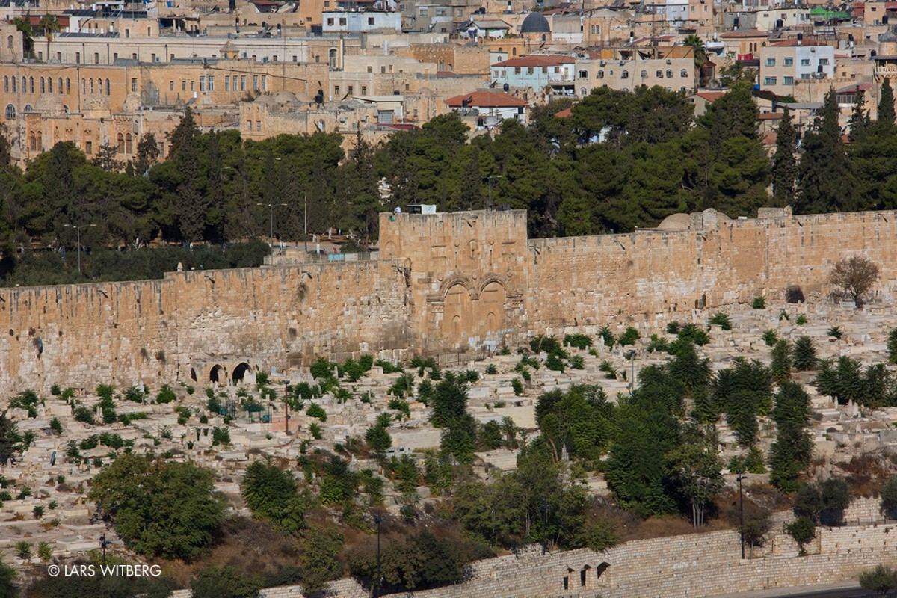
This shot is looking west from the mount of Olives across the Kidron Valley to Jerusalem’s Eastern Gate
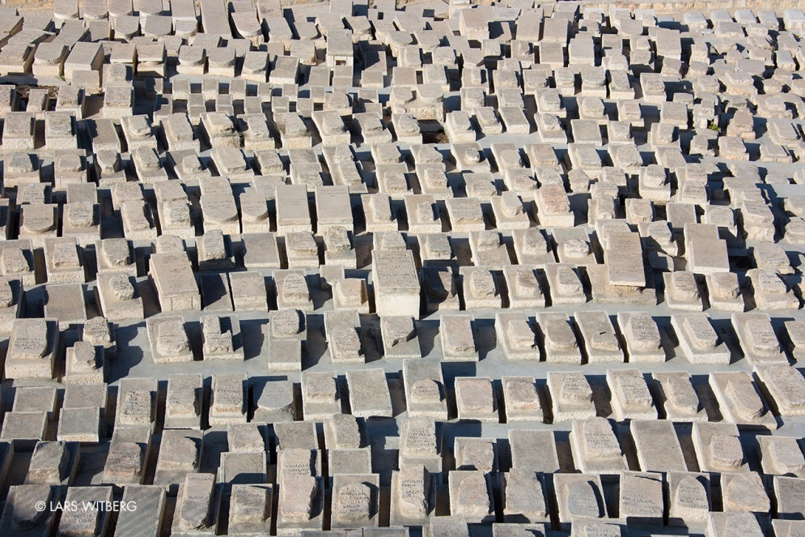
This is a picture of some of the many graves on the valley floor. (Israel and Moslem graves)
Christ will come from the southeast, around Mt. Sanai, up to Edom (Jordon and Bozrah), with stained garments. He will stand on the Mount of Olives, and it will split and a spring of water will gush out, flooding the Kidron Valley. (I’m sure it will wash away the Moslem graves). Old Testament saints will be resurrected at this time (Daniel 12). Christ will then cross the Kidron Valley and enter Jerusalem by the Eastern Gate that has been sealed for centuries. He is King of Kings and Lord of Lords

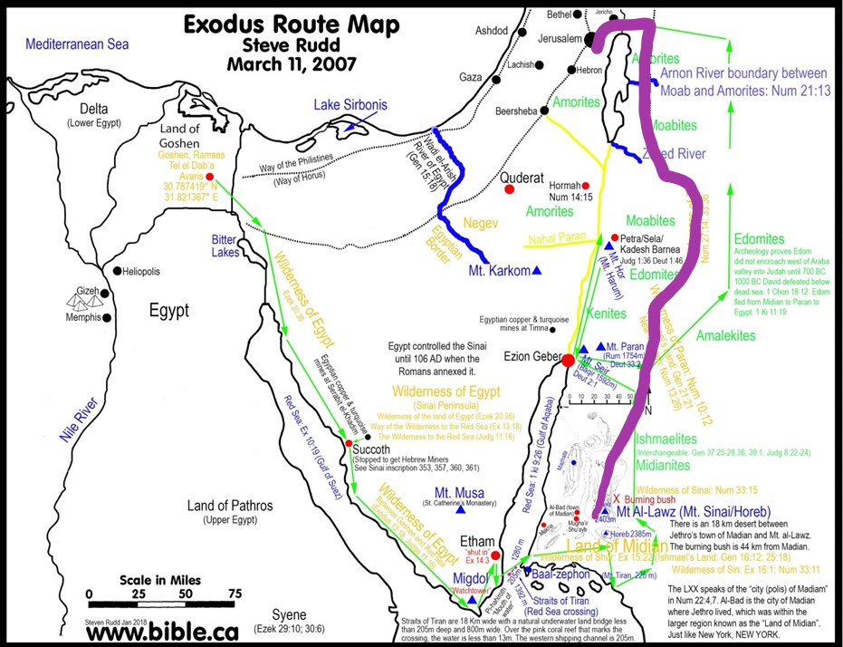

Deuteronomy 33: 2 And he said, The LORD came from Sinai, and rose up from Seir unto them; he shined forth from mount Paran, and he came with ten thousands of saints: from his right hand went a fiery law for them.

Isaiah 34:6 The sword of the LORD is filled with blood, it is made fat with fatness, and with the blood of lambs and goats, with the fat of the kidneys of rams: for the LORD hath a sacrifice in Bozrah, and a great slaughter in the land of Idumea.

Isaiah 63:1 Who is this that cometh from Edom, with dyed garments from Bozrah? this that is glorious in his apparel, travelling in the greatness of his strength? I that speak in righteousness, mighty to save.
Isaiah 63:2 Wherefore art thou red in thine apparel, and thy garments like him that treadeth in the winefat?
Isaiah 63:3 I have trodden the winepress alone; and of the people there was none with me: for I will tread them in mine anger, and trample them in my fury; and their blood shall be sprinkled upon my garments, and I will stain all my raiment.

Zechariah 14:2 For I will gather all nations against Jerusalem to battle; ….
Zechariah 14:4 And his feet shall stand in that day upon the mount of Olives, which is before Jerusalem on the east, and the mount of Olives shall cleave in the midst thereof toward the east and toward the west, and there shall be a very great valley; and half of the mountain shall remove toward the north, and half of it toward the south.

Zephaniah 3:8 for my determination is to gather the nations, that I may assemble the kingdoms, to pour upon them mine indignation, … 9 For then will I turn to the people a pure language, that they may all call upon the name of the LORD, to serve him with one consent.

