Luke 14:11 11 For whosoever exalteth himself shall be abased; and he that humbleth himself shall be exalted…  I Peter 5: 6 Humble yourselves therefore under the mighty hand of God, that he may exalt you in due time: | 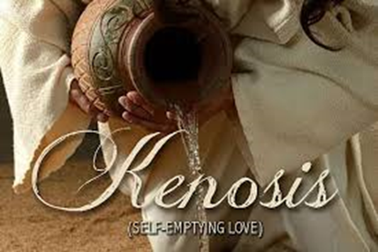
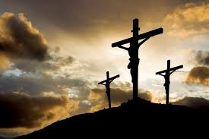 | Philippians 2:6 Who, being in the form of God, thought it not robbery to be equal with God:  Philippians 2:7 But made himself of no reputation, and took upon him the form of a servant, and was made in the likeness of men:  Philippians 2:8 And being found in fashion as a man, he humbled himself, and became obedient unto death, even the death of the cross.  No One Can Get Any Lower Than This
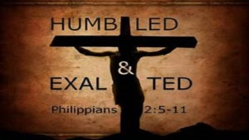
Philippians 2:9 Wherefore God also hath highly exalted him, and given him a name which is above every name:  Philippians 2:10 That at the name of Jesus every knee should bow, of things in heaven, and things in earth, and things under the earth;  Philippians 2:11 And that every tongue should confess that Jesus Christ is Lord, to the glory of God the Father.  No One Can Get Any Higher Than That | 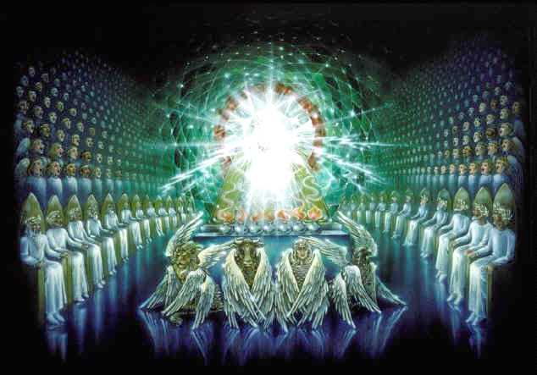
Philippians 3:8 Yea doubtless, and I count all things but loss for the excellency of the knowledge of Christ Jesus my Lord: for whom I have suffered the loss of all things, and do count them but dung, that I may win Christ,
Philippians 3:9 ¶ And be found in him, not having mine own righteousness, which is of the law, but that which is through the faith of Christ, the righteousness which is of God by faith:
Philippians 3:10 That I may know him, and the power of his resurrection, and the fellowship of his sufferings, being made conformable unto his death;
Philippians 3:11 If by any means I might attain unto the resurrection of the dead.
Philippians 3:12 Not as though I had already attained, either were already perfect: but I follow after, if that I may apprehend that for which also I am apprehended of Christ Jesus.
Philippians 3:13 Brethren, I count not myself to have apprehended: but this one thing I do, forgetting those things which are behind, and reaching forth unto those things which are before,
Philippians 3:14 I press toward the mark for the prize of the high calling of God in Christ Jesus.
Philippians 3:15 Let us therefore, as many as be perfect, be thus minded: and if in anything ye be otherwise minded, God shall reveal even this unto you.
Philippians 3:16 Nevertheless, whereto we have already attained, let us walk by the same rule, let us mind the same thing.

This Day Have I Begotten Thee – The Definition of Begotten

This Psalm Can Be Neatly Separated Into Four Sections Consisting Of Three Verses Each – Note the Speaker Change

The Father Is the Speaker
Psalm 2:1 Why do the heathen rage, and the people imagine a vain thing?
Psalm 2:2 The kings of the earth set themselves, and the rulers take counsel together, against the LORD, and against his anointed, saying,
Psalm 2:3 Let us break their bands asunder, and cast away their cords from us.

The Son Speaks of the Father
Psalm 2:4 He that sitteth in the heavens shall laugh: the Lord shall have them in derision.
Psalm 2:5 Then shall he speak unto them in his wrath, and vex them in his sore displeasure.
Psalm 2:6 Yet have I set my king upon my holy hill of Zion.

He Son Speaks of the Father’s Declaration
Psalm 2:7 I will declare the decree: the LORD hath said unto me, Thou art my Son; this day have I begotten thee.
Psalm 2:8 Ask of me, and I shall give thee the heathen for thine inheritance, and the uttermost parts of the earth for thy possession.
Psalm 2:9 Thou shalt break them with a rod of iron; thou shalt dash them in pieces like a potter’s vessel.

The Son Admonishes The Heathen Nations
Psalm 2:10 Be wise now therefore, O ye kings: be instructed, ye judges of the earth.
Psalm 2:11 Serve the LORD with fear, and rejoice with trembling.
Psalm 2:12 Kiss the Son, lest he be angry, and ye perish from the way, when his wrath is kindled but a little. Blessed are all they that put their trust in him.

Let’s Look Again At Verses 6-7:
Psalm 2:6 Yet have I set my king upon my holy hill of Zion.
Psalm 2:7 I will declare the decree: the LORD hath said unto me, Thou art my Son; this day have I begotten thee.

We Can Know 2 Things Right Away:

- The Context Is Around the time of Christ’s 2nd Coming and His The Exaltation As King
- This Act of God in ‘Begetting’ Christ Happens in a ‘Day’

God Has Many Sons, but He Has Only One “Only Begotten Son”
I. I am convinced that all people, and especially scholars, read the text and spend little thought and study on some words that sound familiar, because they think they know its meaning. For centuries, the Church thought “begotten” only meant procreation. Modern scholars have taken “begotten” out of their translations, and substitute a falsity. A little study will prove this not only false, but WICKED.
- The term ‘begotten’ concerning Christ originates in Psalm 2
- Except in type which we will consider later
- The Modern Versions only confuse the issue:
- Context is 2nd Coming (The NIV says, “Today I have become your father” and took out the word ‘begotten’)
- This implies that Christ had a beginning, a complete fallacy and completely wrong because Christ is Eternal. As long as the Father has been the Father (Forever), the Son has been the Son:
John 1: 1 In the beginning was the Word, and the Word was with God, and the Word was God.
John 1: 2 The same was in the beginning with God.
John 1: 3 All things were made by him; and without him was not anything made that was made.
Colossians 2: 9 For in him dwelleth all the fulness of the Godhead bodily.

- It will become obvious that the translators of the modern versions do not understand the word begotten in the KJV

John 1:18 No man hath seen God at any time; the only begotten Son, which is in the bosom of the Father, he hath declared him..

- You will not see the word ‘begotten’ in the NIV. They take it out completely and replace it with ‘One and Only’
- God’s Word should not be treated this way. Taking out a theological term that has been in the English language for 400 years and replace it with something that is completely FALSE.
- Jesus Christ is not God’s One and Only Son! - Here’s 3 examples:

- In Luke 3 Adam is called a “son of God”
- In Genesis 6 and Job Chapter 1 & 6 Angels are called “sons of God”
- In Exodus 4:22 Israel is called firstborn son of God

- In Fact Jesus is not God’s One and Only Son in the NIV!

- In the same chapter (John chapter 1) that the NIV takes out begotten, we are told that we can become “sons of God”

John 1: 12 But as many as received him, to them gave he power to become the sons of God, even to them that believe on his name:

II. The Definition of Begotten - In the Old and New Testaments the Word “Begotten” Has Two Meanings.
- 1st Meaning: A generation or procreation. In other words ‘having a child’
1.) Genesis 4:18 (First Mention) - And unto Enoch was born Irad: and Irad begat Mehujael: and Mehujael begat Methusael: and Methusael begat Lamech.
2.) Genesis 5:3 (And on and on) - And Adam lived an hundred and thirty years, and begat a son in his own likeness, after his image; and called his name Seth:
- 2nd^{t} Meaning: An Exaltation or Elevation of place or rank. The explanation of this meaning begins in the Old Testament and finishes in the New Testament.
Genesis 22:1 And it came to pass after these things, that God did tempt Abraham, and said unto him, Abraham: and he said, Behold, here I am.
Genesis 22:2 And he said, Take now thy son, thine only son Isaac, whom thou lovest, and get thee into the land of Moriah; and offer him there for a burnt offering upon one of the mountains which I will tell thee of.
Genesis 22:3 And Abraham rose up early in the morning, and saddled his ass, and took two of his young men with him, and Isaac his son, and clave the wood for the burnt offering, and rose up, and went unto the place of which God had told him.
Genesis 22:4 Then on the third day Abraham lifted up his eyes, and saw the place afar off.

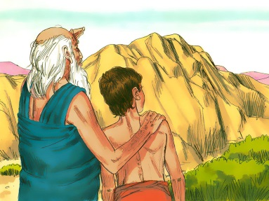

Genesis 22:5 And Abraham said unto his young men, Abide ye here with the ass; and I and the lad will go yonder and worship, and come again to you.
Genesis 22:6 And Abraham took the wood of the burnt offering, and laid it upon Isaac his son; and he took the fire in his hand, and a knife; and they went both of them together.

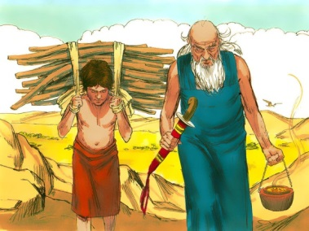 | 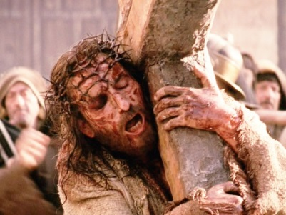

Genesis 22:7 And Isaac spake unto Abraham his father, and said, My father: and he said, Here am I, my son. And he said, Behold the fire and the wood: but where is the lamb for a burnt offering?

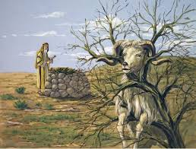

Genesis 22:8 And Abraham said, My son, God will provide himself a lamb for a burnt offering: so they went both of them together.
Genesis 22: 9 And they came to the place which God had told him of; and Abraham built an altar there, and laid the wood in order, and bound Isaac his son, and laid him on the altar upon the wood.
Genesis 22:10 And Abraham stretched forth his hand, and took the knife to slay his son.
Genesis 22: 11 ¶ And the angel of the LORD called unto him out of heaven, and said, Abraham, Abraham: and he said, Here am I.
Genesis 22: 12 And he said, Lay not thine hand upon the lad, neither do thou any thing unto him: for now I know that thou fearest God, seeing thou hast not withheld thy son, thine only son from me.
Genesis 22: 13 And Abraham lifted up his eyes, and looked, and behold behind him a ram caught in a thicket by his horns: and Abraham went and took the ram, and offered him up for a burnt offering in the stead of his son.
Genesis 22:14 And Abraham called the name of that place Jehovahjireh: as it is said to this day, In the mount of the LORD it shall be seen.

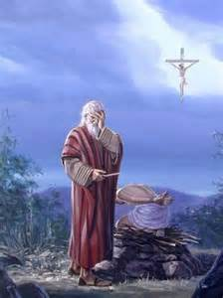

God Preached the Gospel To Abraham in a figure

Isaac a Type of Christ
Isaac | Christ
Isaac’s birth was miraculous – against nature – Genesis 18:11; Romans 4: 18-19; Hebrews 11:11 | Christ was born of a virgin – against nature - Matthew 1:20&21; Isaiah 7:14
Isaac was promised long before he was born – 25 years went by - Genesis 12:1-3 | Jesus was promised many, many years before. – 4000 years went by Genesis 3:15; Isaiah 7:14
Isaac’s birth seemed delayed, but He was born at God’s appointed time. - Genesis 21:1&2 | His birth seemed delayed, but He was born at God’s appointed time.- Galatians 4:4
Isaac’s name was announced before he was born - Genesis 17:19 | Jesus’ name was announced before he was born - Matthew 1:20&21
Abraham was confused when God promised him a son in his old age, his wife was passed the years of child bearing. - Genesis 17:15-17 | When Joseph found Mary with child, he was equally confused, his wife not being with a man - Matthew 1:19-20
Sarah, before her supernaturally conceived son was born, thought it to be impossible – Genesis 18:13 | Mary, before her supernaturally conceived son was born, thought it to be impossible - Luke 1:34
The Angel – (God) – announced to Sarah Genesis 18:14: “Is anything too hard for the Lord?” | The angel announced to Mary Luke 1:37 For with God nothing shall be impossible.
The father’s beloved son - Genesis 22:2 “Take now thy son, thine only son Isaac, whom thou lovest…”(Hebrews 11:17-18) | The Father’s beloved Son Luke 3:22 “… ‘Thou art my beloved Son; in thee I am well pleased.” (John 3:16)
God’s chosen place was Mt. Moriah - Genesis 22:2 | Moriah is in the same place as Mt. Calvary - II Chronicles 3:1
For three days, in Abraham’s mind, Isaac was as good as dead, because it was a three day journey to Moriah. - Genesis 22: 4; Hebrews 11: 12-13 | “…that he was buried and that he rose again the third day, according to the Scriptures. I Corinthians 15:3-4
The entire transaction was solely between father and son. – Only Abraham and Isaac went up the Mount Genesis 22:5 | The last three hours no human saw what happened between Father & Son - Matthew 27:45-46
Isaac carried the wood upon which he would be sacrificed - Genesis 22:6 | Jesus carried the cross upon which He would be sacrificed - John 19:17
The sacrificial lamb was provided by God - Genesis 22:8 | The Sacrificial Lamb was provided by God- John 1:29
A figure of substitution - double type – Isaac and the ram - Genesis 22:13 | A true substitution - Isaiah 53:5,6; II Corinthians 5:21; I Peter 2:24
Isaac rose from the altar a type of resurrection - Genesis 22:13;Hebrews11:19 | “… he rose again the third day, according to the Scriptures. I Corinthians 15:3-4
Genesis 22:14“And Abraham called the name of that place Jehovahjireh: as it is said to this day, In the mount of the LORD it shall be seen.” | John 8:56 “Your father Abraham rejoiced to see my day: and he saw it, and was glad.”
Hebrews 11:17 By faith Abraham, when he was tried, offered up Isaac: and he that had received the promises offered up his only begotten son,
Hebrews 11:18 Of whom it was said, That in Isaac shall thy seed be called:
Hebrews 11:19 Accounting that God was able to raise him up, even from the dead; from whence also he received him in a figure.
Did Abraham Understand God’s Message?
Genesis 22:14“And Abraham called the name of that place Jehovahjireh: as it is said to this day, In the mount of the LORD it shall be seen.”

III. The use of both definitions – Translators of modern versions evidently did not understand “Begotten”, so they took it out of the Word of God.

To reiterate what we have learned, the Hebrew word Yalad (translated ‘begotten’ in the KJV in Psalm 2 and Genesis 22:2) has two definitions. Of course, we can find out which definition is used in a particular Passage, by consulting the context. Both definitions are apparent in the life of Isaac as demonstrated in the chart above.

The first definition is apparent as God tells Abraham,

“Take now thy son, thine only son Isaac, whom thou lovest, and get thee into the land of Moriah; and offer him there for a burnt offering upon one of the mountains which I will tell thee of.” (Genesis 22:2)

The second definition is apparent in:
Hebrews 11:17 By faith Abraham, when he was tried, offered up Isaac: and he that had received the promises offered up his only begotten son,
Hebrews 11:18 Of whom it was said, That in Isaac shall thy seed be called:
Hebrews 11:19 Accounting that God was able to raise him up, even from the dead; from whence also he received him in a figure.

The first definition means that Isaac was Abraham’s son, but you know, Isaac was not Abraham’s only son. Remember Ismael, the son from Hagar? Isaac was God’s choice for the family line that leads to Christ the Messiah. In that since, Isaac was the only son begotten by Abraham in the first sense.

The second definition is apparent as Isaac played the part as a type of Christ, so Abraham could believe in the resurrection of his son. After the angel stopped Abraham, Isaac was elevated to begotten as Christ would be begotten by the Father at His resurrection.

So, Isaac was not Abraham’s only son, but Isaac was Abraham’s only begotten son.

IV. ‘Begotten’ is a very important theological term, and that is probably why the “newer versions” eliminate the term from their perversions. Some versions eliminate the term and substitute “only son” or “unique son”, but most notably the NIV eliminates the term, begotten, and substitutes “one and only son.” Here are a few statements that we must not forget about this:
- Jesus is not God’s One and Only Son!
- In Luke 3:38 – Adam is called “the son of God”
- In Genesis 6 and Job 38 – “Angels are called the sons of God”
- In Exodus 4:22 – Israel is called the “firstborn son of God”
- Jesus is not God’s One and only Son in the NIV! (In the same chapter that the NIV calls Jesus God’s One and Only Son (John 1), in verse 12, states that we can receive the power to become children of God.
- The translators of the NIV do not realize that:
Jesus is not “God’s one and only Son”, but that He is “God’s Only Begotten Son”, and the only One Begotten of God in the flesh. Thank God the KJV translators understood “Begotten”.
- Adam was the “son of God”, but he was not born with that title. (Adam was not born, but preceded from God by creation.)
- Angels were “sons of God” but as Hebrews 1:5 tells us:
Hebrews 1:5 For unto which of the angels said he at any time, Thou art my Son, this day have I begotten thee? And again, I will be to him a Father, and he shall be to me a Son?
- Israel was not begotten in the first sense, but was elevated by God above all other nations.(Exodus 4:22)
- When believers are begotten, the two definitions come together:
James 1: 18 Of his own will begat he us with the word of truth, that we should be a kind of firstfruits of his creatures.
I Peter 1:3 Blessed be the God and Father of our Lord Jesus Christ, which according to his abundant mercy hath begotten us again unto a lively hope by the resurrection of Jesus Christ from the dead,
In the believer, the two definitions seem to happen simultaneously, but In Jesus Christ the two definitions are highly contrasted.
V. In the First Definition of “Begotten”, is found the Beginning of the Most Profound Humiliation.
Philippians 2:6 Who, being in the form of God, thought it not robbery to be equal with God:
Philippians 2:7 But made himself of no reputation, and took upon him the form of a servant, and was made in the likeness of men:

- He is God, but came down to be born a man – Let’s consider a few facts concerning this:
- He was born poor
- He was born in a stable
- Had to flee to Egypt
- Raised in Nazareth, a fishing town
- He became a servant to people who would reject Him
- But this was only the beginning of His humiliation
- He Became Obedient:

Philippians 2: 8 And being found in fashion as a man, he humbled himself, and became obedient unto death, even the death of the cross.
I John 4: 9 In this was manifested the love of God toward us, because that God sent his only begotten Son into the world, that we might live through him.

- He was stripped naked, nailed to a cross with thieves, and made a public spectacle
- He was whipped, a spear thrust in His side, and watched as soldiers gambled for his clothes.
No One Could Get Any Lower Than This

IX. The Place of His Most Profound Humiliation, Is Also the Place of His Preeminent Exaltation

Philippians 2: 9 Wherefore God also hath highly exalted him, and given him a name which is above every name:
Philippians 2:10 That at the name of Jesus every knee should bow, of things in heaven, and things in earth, and things under the earth;
Philippians 2:11 And that every tongue should confess that Jesus Christ is Lord, to the glory of God the Father.
No One Could Get Any Higher Than That
VI. When did Christ’s Humiliation End and His Exaltation (Glorification) Begin? We find the answer going through the Gospel of John concerning Christ’s Glorification:
- It could be His ascension according to this verse because it has to do with the Holy Spirit Ascending, or could be His Crucifixion, or resurrection. We’ll have to look further.

John 7:37 In the last day, that great day of the feast, Jesus stood and cried, saying, If any man thirst, let him come unto me, and drink.
John 7:38 He that believeth on me, as the scripture hath said, out of his belly shall flow rivers of living water.
John 7: 39 (But this spake he of the Spirit, which they that believe on him should receive: for the Holy Ghost was not yet given; because that Jesus was not yet glorified.)
- Again, it could be His glorification could be crucifixion, resurrection, or ascension

John 12:14 And Jesus, when he had found a young ass, sat thereon; as it is written,
John 12:15 Fear not, daughter of Sion: behold, thy King cometh, sitting on an ass’s colt.
John 12:16 These things understood not his disciples at the first: but when Jesus was glorified, then remembered they that these things were written of him, and that they had done these things unto him.
- Now We Come To The Hour

John 12: 23 And Jesus answered them, saying, The hour is come, that the Son of man should be glorified.

- The Hour of His Glorification is the Hour of His Crucifixion

John 12: 24 Verily, verily, I say unto you, Except a corn of wheat fall into the ground and die, it abideth alone: but if it die, it bringeth forth much fruit.

- God Was Glorified on the Cross

John 13:31 Therefore, when he was gone out, Jesus said, Now is the Son of man glorified, and God is glorified in him.
John 13:32 If God be glorified in him, God shall also glorify him in himself, and shall straightway glorify him.

- Now, At Christ’s High Priestly Prayer to the Father

John 17:1 These words spake Jesus, and lifted up his eyes to heaven, and said, Father, the hour is come; glorify thy Son, that thy Son also may glorify thee:
John 17:2 As thou hast given him power over all flesh, that he should give eternal life to as many as thou hast given him.
John 17:3 And this is life eternal, that they might know thee the only true God, and Jesus Christ, whom thou hast sent.
John 17:4 I have glorified thee on the earth: I have finished the work which thou gavest me to do.
John 17:5 And now, O Father, glorify thou me with thine own self with the glory which I had with thee before the world was.

- Another Passage Concerning The Crucifixion: (Many believe that this concerns Christ’s Birth, but Look at the Context:
John 3:14 As Moses lifted up the serpent in the wilderness, even so must the Son of man be lifted up:
John 3:15 That whosoever believeth in him should not perish, but have eternal life.
John 3:16 For God so loved the world, that he gave his only begotten Son, that whosoever believeth in him should not perish, but have everlasting life.

- Now, We Have The Reason God Sent His Son To This World:
John 3: 17 For God sent not his Son into the world to condemn the world; but that the world through him might be saved.
John 3:18 He that believeth on him is not condemned: but he that believeth not is condemned already, because he hath not believed in the name of the only begotten Son of God.

The Two Definitions of Begotten Come Together in Christ, So that the End of His Most Profound Humiliation, When He Went Lowest that is Possible, is the Beginning of His Preeminent Exaltation!

Philippians 2: 6 Who, being in the form of God, thought it not robbery to be equal with God:
Philippians 2: 7 But made himself of no reputation, and took upon him the form of a servant, and was made in the likeness of men:
Philippians 2: 8 And being found in fashion as a man, he humbled himself, and became obedient unto death, even the death of the cross.
Philippians 2: 9 Wherefore God also hath highly exalted him, and given him a name which is above every name:
Philippians 2: 10 That at the name of Jesus every knee should bow, of things in heaven, and things in earth, and things under the earth;
Philippians 2: 11 And that every tongue should confess that Jesus Christ is Lord, to the glory of God the Father.
No One Can Get Any Higher Than That!

- Christ Was Begotten At Calvary
Hebrews 5:3 And by reason hereof he ought, as for the people, so also for himself, to offer for sins.
Hebrews 5:4 And no man taketh this honour unto himself, but he that is called of God, as was Aaron.
Hebrews 5:5 So also Christ glorified not himself to be made an high priest; but he that said unto him, Thou art my Son, today have I begotten thee.

- Christ Was Begotten At His Resurrection
Acts 13: 33 God hath fulfilled the same unto us their children, in that he hath raised up Jesus again; as it is also written in the second psalm, Thou art my Son, this day have I begotten thee.

- Christ Was Begotten When He Sat Down At The Right Hand of the Majesty on High
Hebrews 1: 3 Who being the brightness of his glory, and the express image of his person, and upholding all things by the word of his power, when he had by himself purged our sins, sat down on the right hand of the Majesty on high;
Hebrews 1: 4 Being made so much better than the angels, as he hath by inheritance obtained a more excellent name than they.
Hebrews 1: 5 For unto which of the angels said he at any time, Thou art my Son, this day have I begotten thee?
- To Put It Another Way:
- Jesus Came Out of the Grave – Begotten
- Jesus Ascended into Heaven – Begotten
- Jesus Became High Priest – Begotten
- One Day, Jesus is Going to Come Back To Mount of Olives and split it in two, and will be the Father’s Only Begotten as King of Kings and Lord of Lords.

VII. Philippians 2 explains Christ’s Humiliation and His Glorification, although that is not the entirety of its message. It was written to teach us how we should THINK. Look at this:

Philippians 2: 5 Let this mind be in you, which was also in Christ Jesus:

- How Does Jesus Christ Think?

Philippians 2: 6 Who, being in the form of God, thought it not robbery to be equal with God:
Philippians 2: 7 But made himself of no reputation, and took upon him the form of a servant, and was made in the likeness of men:
Philippians 2: 8 And being found in fashion as a man, he humbled himself, and became obedient unto death, even the death of the cross.

- After Christ became Obedient unto Death, what happened to Him?

Philippians 2:9 Wherefore God also hath highly exalted him, and given him a name which is above every name:
Philippians 2:10 That at the name of Jesus every knee should bow, of things in heaven, and things in earth, and things under the earth;
Philippians 2:11 And that every tongue should confess that Jesus Christ is Lord, to the glory of God the Father.
Christ Only Went As High As He Went Low

- How Do We Think Like Christ? (Beware, this goes against modern thought and Psychology)

Philippians 2: 1 If there be therefore any consolation in Christ, if any comfort of love, if any fellowship of the Spirit, if any bowels and mercies,
Philippians 2: 2 Fulfil ye my joy, that ye be likeminded, having the same love, being of one accord, of one mind.
Philippians 2: 3 Let nothing be done through strife or vainglory; but in lowliness of mind let each esteem other better than themselves.
Philippians 2: 4 Look not every man on his own things, but every man also on the things of others.
Philippians 2: 5 Let this mind be in you, which was also in Christ Jesus:

- Humility is the first step:

I Peter 5:6 Humble yourselves therefore under the mighty hand of God, that he may exalt you in due time:
Luke 14:11 For whosoever exalteth himself shall be abased; and he that humbleth himself shall be exalted.
Proverbs 18:12 Before destruction the heart of man is haughty, and before honour is humility.

- Jesus Christ’s Throne was promised from eternity, but before the Crown there had to be a Cross, and it is the same for us. We must be made conformable unto His death:

Philippians 3: 8 Yea doubtless, and I count all things but loss for the excellency of the knowledge of Christ Jesus my Lord: for whom I have suffered the loss of all things, and do count them but dung, that I may win Christ,
Philippians 3: 9 ¶ And be found in him, not having mine own righteousness, which is of the law, but that which is through the faith of Christ, the righteousness which is of God by faith:
Philippians 3: 10 That I may know him, and the power of his resurrection, and the fellowship of his sufferings, being made conformable unto his death;
Philippians 3: 11 If by any means I might attain unto the resurrection of the dead.
Philippians 3: 12 Not as though I had already attained, either were already perfect: but I follow after, if that I may apprehend that for which also I am apprehended of Christ Jesus.

Galatians 2:20 I am crucified with Christ: nevertheless I live; yet not I, but Christ liveth in me: and the life which I now live in the flesh I live by the faith of the Son of God, who loved me, and gave himself for me.

I have heard many exhort by saying, “What would Jesus do?” But Philippians teaches us to say, “What would Jesus THINK.”

