Contrasting Two Victorious Kings
Chapter 9 is the perfect introduction to the final major division in the Book of Zechariah. In this major division, the Lord contrasts two conquerors of the world. First, the Lord gives an account of the probably the most brilliant human conqueror, who conquered the world by the time he was 33 years old, with the Lord Jesus Christ Who has an eternal, righteous Kingdom. In this comparison, the Lord uses many prophetical methods, the most obvious method, we can also read about Christ using this method teaching in the Temple in the Gospel of Luke:
Luke 4:16 And he came to Nazareth, where he had been brought up: and, as his custom was, he went into the synagogue on the sabbath day, and stood up for to read.
Luke 4:17 And there was delivered unto him the book of the prophet Esaias. And when he had opened the book, he found the place where it was written,
Luke 4:18 The Spirit of the Lord is upon me, because he hath anointed me to preach the gospel to the poor; he hath sent me to heal the brokenhearted, to preach deliverance to the captives, and recovering of sight to the blind, to set at liberty them that are bruised,
Luke 4:19 To preach the acceptable year of the Lord.
Luke 4:20 And he closed the book, and he gave it again to the minister, and sat down. And the eyes of all them that were in the synagogue were fastened on him.
Luke 4:21 And he began to say unto them, This day is this scripture fulfilled in your ears.
Now, why would Jesus read only a portion of a Passage and close the book in the middle of a sentence? The crowd in the Temple were amazed that anyone would do such a thing. And then to make such a summarization after He closed the Book was truly astonishing. Look at their reaction:
Luke 4:22 And all bare him witness, and wondered at the gracious words which proceeded out of his mouth. And they said, Is not this Joseph's son?
Why would Christ do such a thing? This could be construed to be the action of one pulling Scripture out of context! Well to understand Jesus method of teaching prophecy, we need to read the Passage in Isaiah The part that Jesus read is in bold type, what He omitted is in regular type:
Isaiah 61:1 The Spirit of the Lord GOD is upon me; because the LORD hath anointed me to preach good tidings unto the meek; he hath sent me to bind up the brokenhearted, to proclaim liberty to the captives, and the opening of the prison to them that are bound;
Isaiah 61:2 To proclaim the acceptable year of the LORD, and the day of vengeance of our God; to comfort all that mourn;
Isaiah 61:3 To appoint unto them that mourn in Zion, to give unto them beauty for ashes, the oil of joy for mourning, the garment of praise for the spirit of heaviness; that they might be called trees of righteousness, the planting of the LORD, that he might be glorified.
Isaiah 61:4 And they shall build the old wastes, they shall raise up the former desolations, and they shall repair the waste cities, the desolations of many generations.
Isaiah 61:5 And strangers shall stand and feed your flocks, and the sons of the alien shall be your plowmen and your vinedressers.
Isaiah 61:6 But ye shall be named the Priests of the LORD: men shall call you the Ministers of our God: ye shall eat the riches of the Gentiles, and in their glory shall ye boast yourselves.
You see, Christ was telling them that He was here on Earth at His First Advent. He omitted the part of the Passage related to His Second Advent. Truly this is a remarkable situation, and we will find out that this same Jesus used this same method in Zechariah chapter 9.
If the people would have understood this teaching, they would not have yelled crucify Him, effectively killing their promised Messiah. It is just as important today. Knowing this teaching of Christ should motivate us to “Look for His Appearing” as we are instructed so many times in the New Testament.
- Judgment on the Nations surrounding Judah –Judgement on Syria
The Contrast Begins With The Exploits of Alexander the Great. | 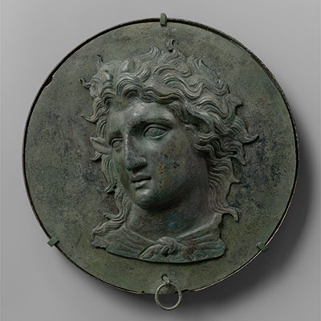

Zechariah 9:1 The burden of the word of the LORD in the land of Hadrach, and Damascus shall be the rest thereof: when the eyes of man, as of all the tribes of Israel, shall be toward the LORD.
Zechariah 9:2a And Hamath also shall border thereby;
These cities mentioned trace the route of the armies of Alexander the Great when he conquered this region. Alexander’s march through this area was in 332-331 B.C.
- Judgment on Tyrus and Zidon – Phoenicia
Zechariah 9:2b…Tyrus, and Zidon, though it be very wise.
Zechariah 9:3 And Tyrus did build herself a strong hold, and heaped up silver as the dust, and fine gold as the mire of the streets.
Zechariah 9:4 Behold, the Lord will cast her out, and he will smite her power in the sea; and she shall be devoured with fire.
Tyrus and Sidon were the two major cities north of Israel, in the land of Lebanon. Tyre was an important commercial city that was thought of as impossible to conquer. The Assyrians laid siege against Tyre for five years, but never conquered the city. Nebuchadnezzar tried for 13 years to conquer Tyre, but Alexander did it in seven months.
Alexander the Great conquered Tyre by laying siege for seven months, using the rubble from the old city to make a causeway out to the island city. It was a spectacular achievement of both military and engineering strategy.
- Judgment on the Philistines
Zechariah 9:5 Ashkelon shall see it, and fear; Gaza also shall see it, and be very sorrowful, and Ekron; for her expectation shall be ashamed; and the king shall perish from Gaza, and Ashkelon shall not be inhabited.
Zechariah 9:6 And a bastard shall dwell in Ashdod, and I will cut off the pride of the Philistines.
Zechariah 9:7 And I will take away his blood out of his mouth, and his abominations from between his teeth: but he that remaineth, even he, shall be for our God, and he shall be as a governor in Judah, and Ekron as a Jebusite.

- The Contrast of the Eternal Victorious King
- The Lord will ”Encamp about mine House”
Zechariah 9:8 And I will encamp about mine house because of the army, because of him that passeth by, and because of him that returneth: and no oppressor shall pass through them any more: for now have I seen with mine eyes.
The Lord will protect that little Temple that the people were building. This should be an encouragement to the people to continue on in the work of the Lord.

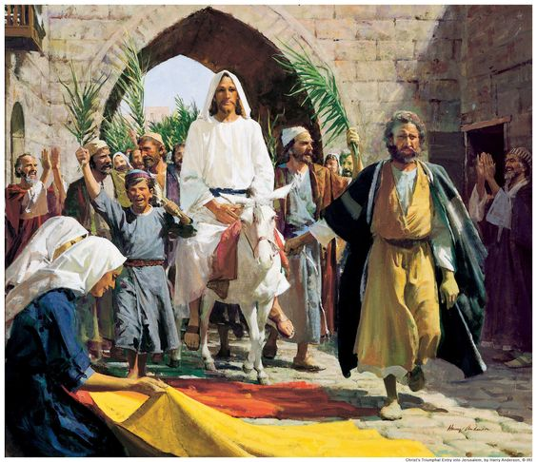

Zechariah 9:9 Rejoice greatly, O daughter of Zion; shout, O daughter of Jerusalem: behold, thy King cometh unto thee: he is just, and having salvation; lowly, and riding upon an ass, and upon a colt the foal of an ass. (Salvation talking about a King needs be understood Deliverance)
Notice how Matthew Quotes Zechariah:
Matthew 21:4 All this was done, that it might be fulfilled which was spoken by the prophet, saying,
Matthew 21:5 Tell ye the daughter of Sion, Behold, thy King cometh unto thee, meek, and sitting upon an ass, and a colt the foal of an ass.
Notice what Matthew leaves out: 1.) Rejoice greatly O daughter of Zion 2.) Shout, O Daughter of Jerusalem 3.) He is just 4.) Having salvation – All that would happen at the second Advent of Christ
John 12:15 Fear not, daughter of Sion: behold, thy King cometh, sitting on an ass’s colt. – John leaves out the same statements as Matthew. Only portrays the First Advent. This same Jesus did the same thing when He was on earth in the Temple, and Luke wrote the account of Christ reading from the scroll of Isaiah. Jesus also, wanted to teach only the First Advent.
Notice also Christ was not meek because he rode in on a donkey. He was of course, meek, but not because of the donkey. The donkey was used to fulfill Scripture, but also because He wanted to teach He was on His Fist Advent only at this time. There were others who rode donkeys in the Bible. The donkey was actually a Royal animal. Kings rode a white donkey to denote peace.
1. Jair, a judge in Israel, had thirty sons that rode on donkeys:
Judges 10:3 And after him arose Jair, a Gileadite, and judged Israel twenty and two years.
Judges 10:4 And he had thirty sons that rode on thirty ass colts, and they had thirty cities, which are called Havothjair unto this day, which are in the land of Gilead.2. Adbon, a judge in Israel, had forty sons and thirty nephews that rode on donkeys:
2. Abdon had 40 sons and thirty nephews all riding on donkeys
Judges 12:13 And after him Abdon the son of Hillel, a Pirathonite, judged Israel.
Judges 12:14 And he had forty sons and thirty nephews, that rode on threescore and ten ass colts: and he judged Israel eight years.
3. King Solomon rode on David's mule for his inauguration as King. This story is similar to how Jesus rode into Jerusalem:
I Kings 1:32 And king David said, Call me Zadok the priest, and Nathan the prophet, and Benaiah the son of Jehoiada. And they came before the king.
I Kings 1:33 The king also said unto them, Take with you the servants of your lord, and cause Solomon my son to ride upon mine own mule, and bring him down to Gihon:
I Kings 1:37 As the LORD hath been with my lord the king, even so be he with Solomon, and make his throne greater than the throne of my lord king David.
I Kings 1:38 So Zadok the priest, and Nathan the prophet, and Benaiah the son of Jehoiada, and the Cherethites, and the Pelethites, went down, and caused Solomon to ride upon king David’s mule, and brought him to Gihon.

Zechariah 9:10 And I will cut off the chariot from Ephraim, and the horse from Jerusalem, and the battle bow shall be cut off: and he shall speak peace unto the heathen: and his dominion shall be from sea even to sea, and from the river even to the ends of the earth.

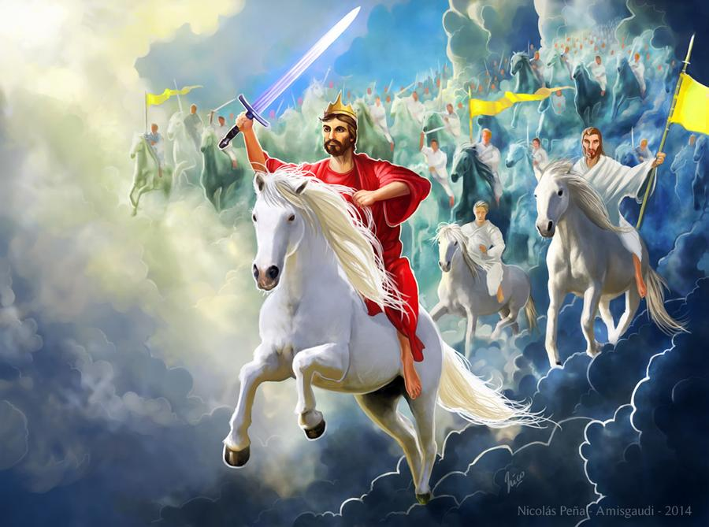

There will not be peace until the Prince of Peace Returns and sets up His Kingdom

God will Deliver His People at the Second Advent
Zechariah 9:11 As for thee also, by the blood of thy covenant I have sent forth thy prisoners out of the pit wherein is no water.
Zechariah 9:12 Turn you to the strong hold, ye prisoners of hope: even today do I declare that I will render double unto thee;
Zechariah 9:13 When I have bent Judah for me, filled the bow with Ephraim, and raised up thy sons, O Zion, against thy sons, O Greece, and made thee as the sword of a mighty man.
Zechariah 9:14 And the LORD shall be seen over them, and his arrow shall go forth as the lightning: and the Lord GOD shall blow the trumpet, and shall go with whirlwinds of the south.
Zechariah 9:15 The LORD of hosts shall defend them; and they shall devour, and subdue with sling stones; and they shall drink, and make a noise as through wine; and they shall be filled like bowls, and as the corners of the altar.
Zechariah 9:16 And the LORD their God shall save them in that day as the flock of his people: for they shall be as the stones of a crown, lifted up as an ensign upon his land.
Zechariah 9:17 For how great is his goodness, and how great is his beauty! corn shall make the young men cheerful, and new wine the maids.

