The Book of Daniel is sometimes called the Apocalypse of the Old Testament. There are actually four apocalypses in the Bible: Ezekiel, Zechariah, Revelation, and Daniel. The people of God need to be acquainted with this elite group of Scripture, and the lack of teaching prophecy for the last 2000 years has taken its toll on the Christian culture of today. Prophecy comprises one-quarter of all Scripture, and must not be ignored by any of God’s children. If we do not study prophecy, we do not know the Lord Jesus Christ, because it is stated in the Book of Revelation as John is beginning to worship the angel speaking to him:
Revelation:19:10 And I fell at his feet to worship him. And he said unto me, See thou do it not: I am thy fellowservant, and of thy brethren that have the testimony of Jesus: worship God: for the testimony of Jesus is the spirit of prophecy.
Prophecy will enable us to clean up our lives:
I John 3:2 Beloved, now are we the sons of God, and it doth not yet appear what we shall be: but we know that, when he shall appear, we shall be like him; for we shall see him as he is.
I John 3:3 And every man that hath this hope in him purifieth himself, even as he is pure.
The Book of Daniel splits evenly into 2 main sections: the first section contains chapters 1-6 consisting of History with prophetical insight; and secondly, chapters 7-12, containing Prophecy with Historical insight. This book spans the entire time of the 70 year Babylonian Captivity, prophesied by Moses, Isaiah, Habakkuk, and many others. Daniel was obviously sent to Babylon by God to serve as “Prime Minister” for King Nebuchadnezzar from his first year, and continuing on to the first year of the Persian King Cyrus, two different Pagan empires. The very first chapter will explain why Daniel was chosen by God, in His excellent foresight, to carry on this very important job; and should teach us to not be conformed to this world’s culture, philosophy, or psychology, but to be transformed by the renewing of our mind. (Romans 12:1-2). | 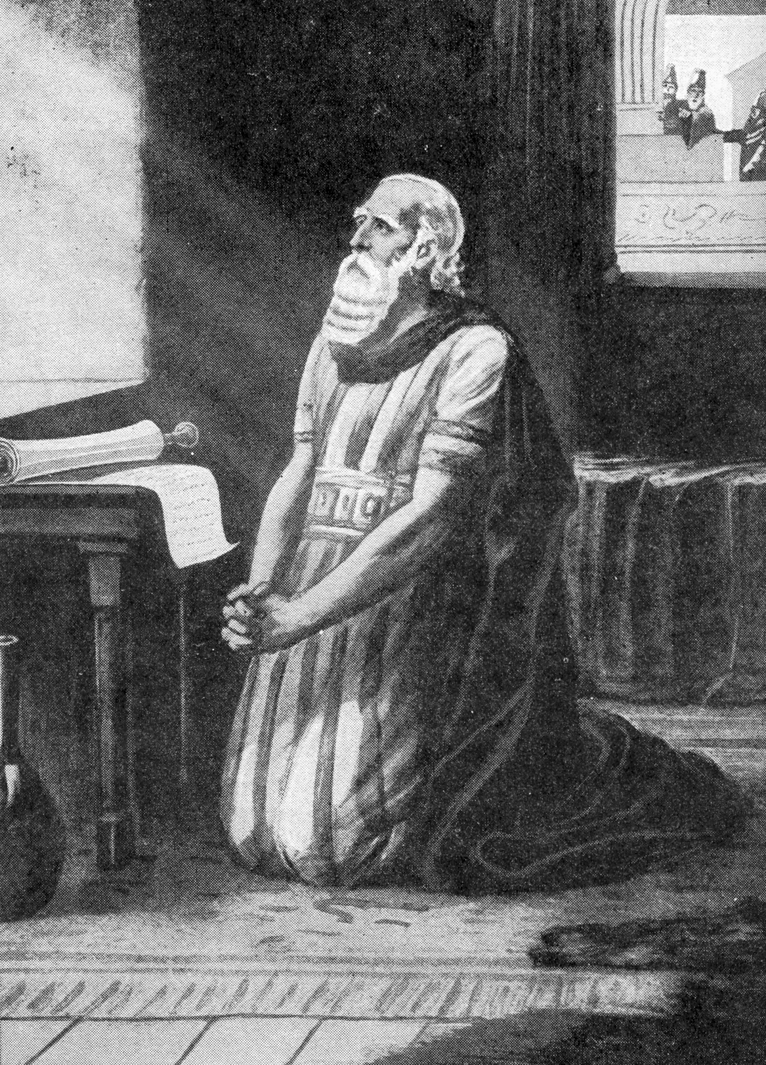
The rest of the book will teach us that God is ultimately in control, and has been in the process of setting up His everlasting Kingdom from the beginning. By a series of prophecies through dreams, visions, types, partial fulfillment, and angelic revelation, we will see God’s plan and purpose unfold.
THE BOOK OF DANIEL – 2nd of Four Apocalypses of the Bible
Subject | History of Daniel | Prophetic Plan For The Gentiles |  |  |  | Prophetic Plan for Israel
Division | History with Prophetical Background |  |  |  | Prophecy with Historical Background
Scripture | 1:1-2:1 | 2:1-5:1 | 5:1-6:1 | 6:1-7:1 | 7:1-8:1 | 8:1-9:1 | 9:1-10:1 | 10:1-12:13
Division | Personal Life of Daniel | Visions of Nebuchadnezzar | Vision of Belshazzar | Decree  of Darius | Four Beasts | Vision of The Ram &  He-goat | Vision of the Seventy Weeks | Setting up the Kingdom
Key | Daniel 2:44 And in the days of these kings shall the God of heaven set up a kingdom, which shall never be destroyed: and the kingdom shall not be left to other people, but it shall break in pieces and consume all these kingdoms, and it shall stand for ever.
Language | Hebrew | Aramaic |  |  |  | Hebrew
Time | Spans the entire Babylonian Captivity - 605-536 BC
Area | Babylon and Persia
- Daniel begins in the third year of King Jehoiakim and Jerusalem Besieged
Daniel 1:1 In the third year of the reign of Jehoiakim king of Judah came Nebuchadnezzar king of Babylon unto Jerusalem, and besieged it. | 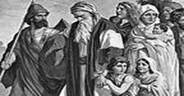
- The historical background begins with King Manasseh and his son-successor Amon
II Chronicles 33:21 Amon was two and twenty years old when he began to reign, and reigned two years in Jerusalem.
II Chronicles 33:22 But he did that which was evil in the sight of the LORD, as did Manasseh his father: for Amon sacrificed unto all the carved images which Manasseh his father had made, and served them;
II Chronicles 33:23 And humbled not himself before the LORD, as Manasseh his father had humbled himself; but Amon trespassed more and more.
II Chronicles 33:24 And his servants conspired against him, and slew him in his own house.
II Chronicles 33:25 But the people of the land slew all them that had conspired against king Amon; and the people of the land made Josiah his son king in his stead.
- Josiah, the son of Amon, on the other hand, was a good King
II Chronicles 34:1 Josiah was eight years old when he began to reign, and he reigned in Jerusalem one and thirty years.
II Chronicles 34:2 And he did that which was right in the sight of the LORD, and walked in the ways of David his father, and declined neither to the right hand, nor to the left.
II Chronicles 34:3 For in the eighth year of his reign, while he was yet young, he began to seek after the God of David his father: and in the twelfth year he began to purge Judah and Jerusalem from the high places, and the groves, and the carved images, and the molten images.
II Chronicles 34:4 And they brake down the altars of Baalim in his presence; and the images, that were on high above them, he cut down; and the groves, and the carved images, and the molten images, he brake in pieces, and made dust of them, and strowed it upon the graves of them that had sacrificed unto them.
II Chronicles 34:5 And he burnt the bones of the priests upon their altars, and cleansed Judah and Jerusalem.
- Josiah repaired the Temple
II Chronicles 34:8 Now in the eighteenth year of his reign, when he had purged the land, and the house, he sent Shaphan the son of Azaliah, and Maaseiah the governor of the city, and Joah the son of Joahaz the recorder, to repair the house of the LORD his God.
- The Book of the Law was Found by Hilkiah
II Chronicles 34:8 Now in the eighteenth year of his reign, when he had purged the land, and the house, he sent Shaphan the son of Azaliah, and Maaseiah the governor of the city, and Joah the son of Joahaz the recorder, to repair the house of the LORD his God.
- When the Word of God was read, King Josiah Mourned
II Chronicles 34:18 Then Shaphan the scribe told the king, saying, Hilkiah the priest hath given me a book. And Shaphan read it before the king.
II Chronicles And it came to pass, when the king had heard the words of the law, that he rent his clothes.
- Why did the King Mourn?
II Chronicles 34:21 Go, enquire of the LORD for me, and for them that are left in Israel and in Judah, concerning the words of the book that is found: for great is the wrath of the LORD that is poured out upon us, because our fathers have not kept the word of the LORD, to do after all that is written in this book.
- King Josiah makes a Covenant with the LORD
II Chronicles 34:30 And the king went up into the house of the LORD, and all the men of Judah, and the inhabitants of Jerusalem, and the priests, and the Levites, and all the people, great and small: and he read in their ears all the words of the book of the covenant that was found in the house of the LORD.
II Chronicles 34:31 And the king stood in his place, and made a covenant before the LORD, to walk after the LORD, and to keep his commandments, and his testimonies, and his statutes, with all his heart, and with all his soul, to perform the words of the covenant which are written in this book.
- Josiah Caused all the People only to Serve the LORD – Revival is here
II Chronicles 34:32 And he caused all that were present in Jerusalem and Benjamin to stand to it. And the inhabitants of Jerusalem did according to the covenant of God, the God of their fathers.
II Chronicles 34:33 And Josiah took away all the abominations out of all the countries that pertained to the children of Israel, and made all that were present in Israel to serve, even to serve the LORD their God. And all his days they departed not from following the LORD, the God of their fathers.
- Josiah Worships the Lord with a Passover – Never a Passover like that one
II Chronicles 35:6 So kill the passover, and sanctify yourselves, and prepare your brethren, that they may do according to the word of the LORD by the hand of Moses.
II 2 Chronicles 35:18 And there was no passover like to that kept in Israel from the days of Samuel the prophet; neither did all the kings of Israel keep such a passover as Josiah kept, and the priests, and the Levites, and all Judah and Israel that were present, and the inhabitants of Jerusalem.
- The Good King Josiah Dies in Battle
II Chronicles 35:20 After all this, when Josiah had prepared the temple, Necho king of Egypt came up to fight against Carchemish by Euphrates: and Josiah went out against him.  II 2 Chronicles 35:23 And the archers shot at king Josiah; and the king said to his servants, Have me away; for I am sore wounded. | 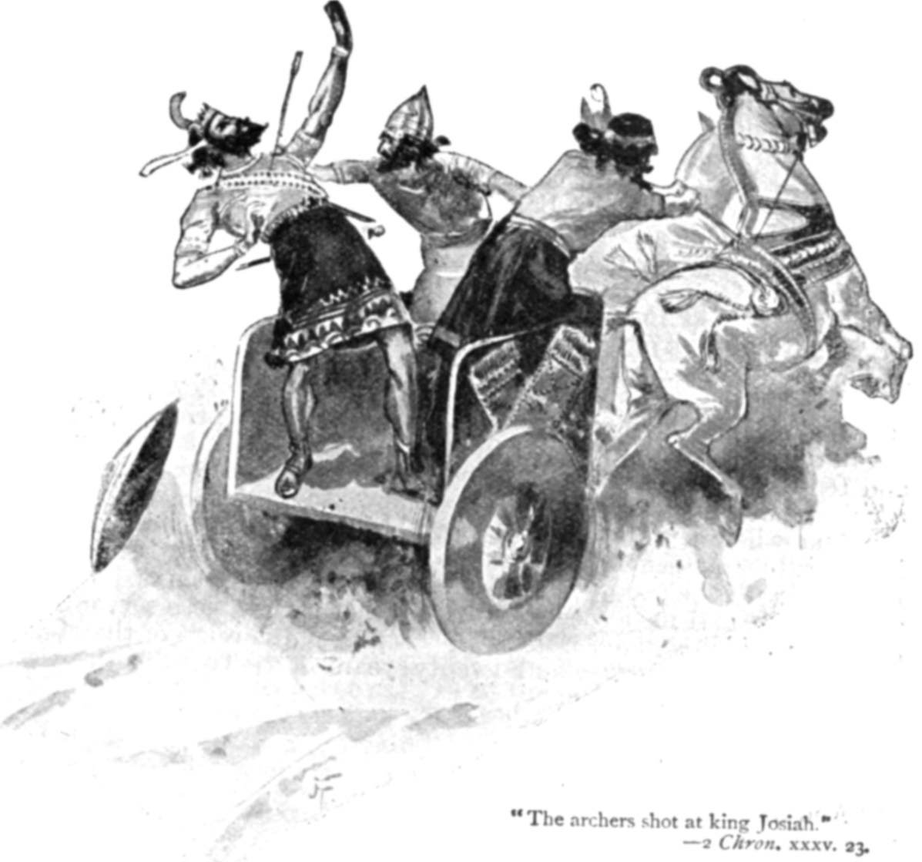
- King Josiah’s Sons, Jehoahaz and Jehoiakim, Reign in Judah
- Jehoahaz Rules for Three Months
II Kings 23:30 And his servants carried him in a chariot dead from Megiddo, and brought him to Jerusalem, and buried him in his own sepulchre. And the people of the land took Jehoahaz the son of Josiah, and anointed him, and made him king in his father's stead.
II Kings 23:34 And Pharaohnechoh made Eliakim the son of Josiah king in the room of Josiah his father, and turned his name to Jehoiakim, and took Jehoahaz away: …
- Jehoiakim Rules
II Chronicles 36:4 And the king of Egypt made Eliakim his brother king over Judah and Jerusalem, and turned his name to Jehoiakim. And Necho took Jehoahaz his brother, and carried him to Egypt.
II Chronicles 36:5 Jehoiakim was twenty and five years old when he began to reign, and he reigned eleven years in Jerusalem: and he did that which was evil in the sight of the LORD his God.  II Chronicles 36:6 Against him came up Nebuchadnezzar king of Babylon, and bound him in fetters, to carry him to Babylon.  II Chronicles 36:7 Nebuchadnezzar also carried of the vessels of the house of the LORD to Babylon, and put them in his temple at Babylon. |  |  |  | 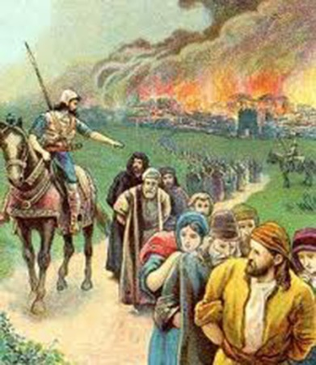
Chronological Table of the Kingdom of Judah
King | Reign | Character | Prophet
1. Rehoboam | 931-913 B.C. (17 yrs.) | Bad | Shemaiah
2. Abijah | 913-911 (3 yrs.) | Bad
3. Asa | 911-870 (41 yrs.) | Good
4. Jehoshaphat | 870-848* (25 yrs.) | Good
5. Jehoram | 848-841* (8 yrs.) | Bad
6. Ahaziah | 841 (1 yr.) | Bad
7. Athaliah | 841-835 (6 yrs.) | Bad
8. Joash | 835-796 (40 yrs.) | Good | Joel
9. Amaziah | 796-767 (29 yrs.) | Good
10. Azariah (or Uzziah) | 767-740* (52 yrs.) | Good | Isaiah
11. Jotham | 740-732* (16 yrs.) | Good | Micah
12. Ahaz | 732-716 (16 yrs.) | Bad
13. Hezekiah | 716-687 (29 yrs.) | Good
14. Manasseh | 687-642* (55 yrs.) | Bad
15. Amon | 642-640 (2 yrs.) | Bad
16. Josiah | 640-608 (31 yrs.) | Good | Nahum, Habakkuk, Zephaniah, Jeremiah
17. Jehoahaz | 608 (3 mos.) | Bad
18. Jehoiakim | 608-597 (11 yrs.) | Bad
19. Jehoiachin | 597 (3 mos.) | Bad
20. Zedekiah | 597-586 (11 yrs.) | Bad
(Destruction of Jerusalem and captivity of Judah)
* Co-regency
- Nebuchadnezzar besieged Jerusalem and took the “Cream of the crop” to Babylon
Daniel 1:2 And the Lord gave Jehoiakim king of Judah into his hand, with part of the vessels of the house of God: which he carried into the land of Shinar to the house of his god; and he brought the vessels into the treasure house of his god.
Daniel 1:3 And the king spake unto Ashpenaz the master of his eunuchs, that he should bring certain of the children of Israel, and of the king's seed, and of the princes;
Daniel 1:4 Children in whom was no blemish, but well favoured, and skilful in all wisdom, and cunning in knowledge, and understanding science, and such as had ability in them to stand in the king's palace, and whom they might teach the learning and the tongue of the Chaldeans.
Daniel 1:5 And the king appointed them a daily provision of the king's meat, and of the wine which he drank: so nourishing them three years, that at the end thereof they might stand before the king.
Daniel 1:6 Now among these were of the children of Judah, Daniel, Hananiah, Mishael, and Azariah:
Daniel 1:7 Unto whom the prince of the eunuchs gave names: for he gave unto Daniel the name of Belteshazzar; and to Hananiah, of Shadrach; and to Mishael, of Meshach; and to Azariah, of Abednego.
Daniel 1:8 But Daniel purposed in his heart that he would not defile himself with the portion of the king's meat, nor with the wine which he drank: therefore he requested of the prince of the eunuchs that he might not defile himself.
III. The First World Empire since the Tower of Babel – Began the Times of the Gentiles
A. God did not permit anyone to conquer the world
1. God confused Babel’s tongues
2. Scattered of the descendants of Noah at Babel
B. God called the Hebrew Nation to be the leading nation of the world
1. A witness to the rest of the world
2. Their disobedience and idolatry prevented this.
C. 721 BC the ten tribes (Northern Kingdom) were captured
1. Deported to Nineveh
2. By King Sargon of Assyria
D. 606 BC, 115 years later, Judah (Southern Kingdom) was captured
1. Deported to Babylon - By Nebuchadnezzar of Babylon
2. Began the 70 years captivity in Babylon as foretold by Jeremiah.
Jeremiah 25:11 And this whole land shall be a desolation, and an astonishment; and these nations shall serve the king of Babylon seventy years.
E. Nations At War Wanting To Be The World Conqueror
1. Babylon had already swallowed up Assyria. (At Carchemish their last stronghold)
2. In BC 605 Pharoh-necho, king of Egypt, marched against Babylon at Carchemish
a. Was overwhelmingly defeated by Nebuchadnezzar
b. The battle of Carchemish on the west bank of the river Euphrates
3. This was foretold by Jeremiah. (Jeremiah 46:1-26)
4. The defeat of Pharoh-necho made Babylon a great empire
III. Daniel And His Friends Deported To Babylon
A. The deportation of Daniel and friends begins with a prophecy by Isaiah to king Hezekiah.
Isaiah 39:1 At that time Merodachbaladan, the son of Baladan, king of Babylon, sent letters and a present to Hezekiah: for he had heard that he had been sick, and was recovered.
Isaiah 39:2 And Hezekiah was glad of them, and shewed them the house of his precious things, the silver, and the gold, and the spices, and the precious ointment, and all the house of his armour, and all that was found in his treasures: there was nothing in his house, nor in all his dominion, that Hezekiah shewed them not.
Isaiah 39:3 Then came Isaiah the prophet unto king Hezekiah, and said unto him, What said these men? and from whence came they unto thee? And Hezekiah said, They are come from a far country unto me, even from Babylon.
Isaiah 39:4 Then said he, What have they seen in thine house? And Hezekiah answered, All that is in mine house have they seen: there is nothing among my treasures that I have not shewed them.
Isaiah 39:5 Then said Isaiah to Hezekiah, Hear the word of the LORD of hosts:
Isaiah 39:6 Behold, the days come, that all that is in thine house, and that which thy fathers have laid up in store until this day, shall be carried to Babylon: nothing shall be left, saith the LORD.
Isaiah 39:7 And of thy sons that shall issue from thee, which thou shalt beget, shall they take away; and they shall be eunuchs in the palace of the king of Babylon.
Isaiah 39:8 Then said Hezekiah to Isaiah, Good is the word of the LORD which thou hast spoken. He said moreover, For there shall be peace and truth in my days.
B. The First Deportation – Daniel And His Friends – Begins “Times of the Gentiles”
1. In 605 B.C. Prince Nebuchadnezzar Takes his father’s troops against Allies Assyria and Egypt
a. He defeated them at Carchemish near the top of the Fertile Crescent.
b. This victory gave Babylon supremacy in the ancient Near East.
c. Now, Egypt's vassals, including Judah, are under Babylonian control.
2. Shortly thereafter that same year Nabopolassar died
a. Nebuchadnezzar succeeded him as king.
b. Nebuchadnezzar then moved south and invaded Judah- in 605 B.C.
c. He took some royal and noble captives to Babylon
d. Some of the vessels from Solomon's temple to Babylon
II Chronicles 36:7 Nebuchadnezzar also carried of the vessels of the house of the LORD to Babylon, and put them in his temple at Babylon.
C. The Second Deportation – The Captivity of Ezekiel
1. The king of Judah at that time was Jehoiakim
II Kings 24:1 In his days Nebuchadnezzar king of Babylon came up, and Jehoiakim became his servant three years: then he turned and rebelled against him.
II Kings 24:2 And the LORD sent against him bands of the Chaldees, and bands of the Syrians, and bands of the Moabites, and bands of the children of Ammon, and sent them against Judah to destroy it, according to the word of the LORD, which he spake by his servants the prophets.
II Kings 24:3 Surely at the commandment of the LORD came this upon Judah, to remove them out of his sight, for the sins of Manasseh, according to all that he did;
II Kings 24:4 And also for the innocent blood that he shed: for he filled Jerusalem with innocent blood; which the LORD would not pardon.
2. Jehoikim’s son Jehoiachin (aka Jeconiah and Coniah) succeeded him in BC 598
a. Jehoiachin reigned only three months and 10 days
II Chronicles. 36:9 Jehoiachin was eight years old when he began to reign, and he reigned three months and ten days in Jerusalem: and he did that which was evil in the sight of the LORD.
b. Nebuchadnezzar invaded Judah again.
c. At the turn of the year BC 597- took Jehoiachin to Babylon
1. With most of Judah's remaining leaders
2. The rest of the national treasures including young Ezekiel
II Kings 24:11 And Nebuchadnezzar king of Babylon came against the city, and his servants did besiege it.
II Kings 24:12 And Jehoiachin the king of Judah went out to the king of Babylon, he, and his mother, and his servants, and his princes, and his officers: and the king of Babylon took him in the eighth year of his reign.
II Kings 24:13 And he carried out thence all the treasures of the house of the LORD, and the treasures of the king’s house, and cut in pieces all the vessels of gold which Solomon king of Israel had made in the temple of the LORD, as the LORD had said.
II Kings 24:14 And he carried away all Jerusalem, and all the princes, and all the mighty men of valour, even ten thousand captives, and all the craftsmen and smiths: none remained, save the poorest sort of the people of the land.
II Kings 24:17 And the king of Babylon made Mattaniah his father’s brother king in his stead, and changed his name to Zedekiah.
II Chronicles. 36:10 And when the year was expired, king Nebuchadnezzar sent, and brought him to Babylon, with the goodly vessels of the house of the LORD, and made Zedekiah his brother king over Judah and Jerusalem.
II Chronicles. 36:11 Zedekiah was one and twenty years old when he began to reign, and reigned eleven years in Jerusalem.
II Chronicles. 36:12 And he did that which was evil in the sight of the LORD his God, and humbled not himself before Jeremiah the prophet speaking from the mouth of the LORD.
II Chronicles. 36:13 And he also rebelled against king Nebuchadnezzar, who had made him swear by God: but he stiffened his neck, and hardened his heart from turning unto the LORD God of Israel.
D. The Third Deportation – The Desolations
1. Approximately 11 years later, in 586 B.C.
2. Zedekiah made Judah’s puppet king
a. Jehoikim's younger brother Zedekiah,
b. Nebuchadnezzar changed his name to Mattaniah,
c. He rebelled against Babylon's sovereignty
1. Secretly made a treaty with Pharaoh-Necho - pressure from Jewish nationalists (Jeremiah 37 - 38).
2. After a two-year siege, Jerusalem fell.
3. Nebuchadnezzar returned to Jerusalem
a. Burned the temple
b. Broke down the city walls
c. Took all but the poorest of the Jews captive to Babylon.
d. He also took Zedekiah prisoner to Babylon
1. He executed his sons
2. Put out the king's eyes at Riblah in Aramea
2 Kings 24:17 And the king of Babylon made Mattaniah his father’s brother king in his stead, and changed his name to Zedekiah.
2 Kings 25:2 And the city was besieged unto the eleventh year of king Zedekiah.
2 Chronicles 36:11 Zedekiah was one and twenty years old when he began to reign, and reigned eleven years in Jerusalem.
Jeremiah 32:3 For Zedekiah king of Judah had shut him up, saying, Wherefore dost thou prophesy, and say, Thus saith the LORD, Behold, I will give this city into the hand of the king of Babylon, and he shall take it;
Jeremiah 37:1 And king Zedekiah the son of Josiah reigned instead of Coniah the son of Jehoiakim, whom Nebuchadrezzar king of Babylon made king in the land of Judah.
4. Ezekiel prophesied about Zedekiah being deported but won’t see Babylon
Ezekiel 12:13 My net also will I spread upon him, and he shall be taken in my snare: and I will bring him to Babylon to the land of the Chaldeans; yet shall he not see it, though he shall die there.
5. Jeremiah explains the prophecy:
Jeremiah 39:6 Then the king of Babylon slew the sons of Zedekiah in Riblah before his eyes: also the king of Babylon slew all the nobles of Judah.
Jeremiah 39:7 Moreover he put out Zedekiah’s eyes, and bound him with chains, to carry him to Babylon.
IV. The Times of the Gentiles – 606 BC -The 1st World-wide Empire ever seen.
- “Times of Gentiles” run through the 2nd Advent –
Luke 21:24 And they shall fall by the edge of the sword, and shall be led away captive into all nations: and Jerusalem shall be trodden down of the Gentiles, until the times of the Gentiles be fulfilled.
- “Times of the Gentiles not the same as “Fulness of the Gentiles”
Romans 11:25 For I would not, brethren, that ye should be ignorant of this mystery, lest ye should be wise in your own conceits; that blindness in part is happened to Israel, until the fulness of the Gentiles be come in.
Romans 11:26 And so all Israel shall be saved: as it is written, There shall come out of Sion the Deliverer, and shall turn away ungodliness from Jacob:
II Corinthians 3:14 But their minds were blinded: for until this day remaineth the same vail untaken away in the reading of the old testament; which vail is done away in Christ.
II Corinthians 3:15 But even unto this day, when Moses is read, the vail is upon their heart.
II Corinthians 3:16 Nevertheless when it shall turn to the Lord, the vail shall be taken away.
B. The Hebrew Captives
Daniel 1:3 And the king spake unto Ashpenaz the master of his eunuchs, that he should bring certain of the children of Israel, and of the king’s seed, and of the princes;
Daniel 1:4 Children in whom was no blemish, but well favoured, and skilful in all wisdom, and cunning in knowledge, and understanding science, and such as had ability in them to stand in the king’s palace, and whom they might teach the learning and the tongue of the Chaldeans.
Daniel 1:5 And the king appointed them a daily provision of the king’s meat, and of the wine which he drank: so nourishing them three years, that at the end thereof they might stand before the king.
Daniel 1:6 Now among these were of the children of Judah, Daniel, Hananiah, Mishael, and Azariah:
Daniel 1:7 Unto whom the prince of the eunuchs gave names: for he gave unto Daniel the name of Belteshazzar; and to Hananiah, of Shadrach; and to Mishael, of Meshach; and to Azariah, of Abednego.
1. Four Hebrew captives – Hebrew names changed
a. Daniel - God is my judge - changed to Belteshazzar - Whom Bell favors
b. Hananiah - Beloved of the Lord - to Shadrach - Illumined by the Sun god
c. Mishael - Who is as God - to Mishach - Who is like Venus
d. Azariah - the Lord is my help - to Abednego - the servant of Nego.
2. They were of royal blood
a. They were descendants of the good king Hezekiah
b. They were made eunuchs - turned over to the ‘Prince of Eunuchs’ for 3 years
3. Prince of Eunuchs changed their names
a. To wean them away from their land and religion
b. Get them to adopt the religion and habits of Heathen Babylon
B. Changing a man’s name does not change his character
IV. Daniel’s Test – Daniel made a decision based on God’s Word not to defile himself
Daniel 1:8 But Daniel purposed in his heart that he would not defile himself with the portion of the king’s meat, nor with the wine which he drank: therefore he requested of the prince of the eunuchs that he might not defile himself.
The word translated “purposed” is the Hebrew word syim <7760>translated in Haggai as “consider”: Literally means to “Put your heart into your ways”.
Haggai 1:2 Thus speaketh the LORD of hosts, saying, This people say, The time is not come, the time that the LORD'S house should be built.
Haggai 1:3 Then came the word of the LORD by Haggai the prophet, saying,
Haggai 1:4 Is it time for you, O ye, to dwell in your cieled houses, and this house lie waste?
Haggai 1:5 Now therefore thus saith the LORD of hosts; Consider<7760> your ways.
Also, in the story of Joseph being the savior for his brethren that sold him into slavery the word is translated “preserve”:
Genesis 45:7 And God sent me before you to preserve<7760> you a posterity in the earth, and to save your lives by a great deliverance.
Now, it’s meaning in each one of these instances means a “Decided Resolution” and each time that decided resolution came about from what God wants.
In Haggai, the meaning is to “put your heart in your ways” and walk how God wants you to walk; In Genesis, the meaning is God Himself is appointing you a posterity; and finally in Daniel, Daniel made a decided and it was resolved that he was going to follow God’s Word on the subject of the Pagan diet and refrain from being a partaker.
What does God’s Word say about Pagan meat? In Daniel’s time the Lord said in Leviticus:
Leviticus 11:44 For I am the LORD your God: ye shall therefore sanctify yourselves, and ye shall be holy; for I am holy: neither shall ye defile yourselves with any manner of creeping thing that creepeth upon the earth.
Leviticus 11:45 For I am the LORD that bringeth you up out of the land of Egypt, to be your God: ye shall therefore be holy, for I am holy.
Leviticus 11:46 This is the law of the beasts, and of the fowl, and of every living creature that moveth in the waters, and of every creature that creepeth upon the earth:
Today, Paul instructs us:
I Corinthians 10:25 Whatsoever is sold in the shambles, that eat, asking no question for conscience sake:
I Corinthians 10:26 For the earth is the Lord's, and the fulness thereof.
I Corinthians 10:27 If any of them that believe not bid you to a feast, and ye be disposed to go; whatsoever is set before you, eat, asking no question for conscience sake.
I Corinthians 10:28 But if any man say unto you, This is offered in sacrifice unto idols, eat not for his sake that shewed it, and for conscience sake: for the earth is the Lord's, and the fulness thereof:
I Corinthians 10:29 Conscience, I say, not thine own, but of the other: for why is my liberty judged of another man's conscience?
I Corinthians 10:30 For if I by grace be a partaker, why am I evil spoken of for that for which I give thanks?
I Corinthians 10:31 Whether therefore ye eat, or drink, or whatsoever ye do, do all to the glory of God.
I Corinthians 10:32 Give none offence, neither to the Jews, nor to the Gentiles, nor to the church of God:
V. God brought Daniel in Favor with the “Prince of the eunuchs”- Decision put to the test
Daniel 1:9 Now God had brought Daniel into favour and tender love with the prince of the eunuchs.  Daniel 1:10 And the prince of the eunuchs said unto Daniel, I fear my lord the king, who hath appointed your meat and your drink: for why should he see your faces worse liking than the children which are of your sort? then shall ye make me endanger my head to the king.  Daniel 1:11 Then said Daniel to Melzar, whom the prince of the eunuchs had set over Daniel, Hananiah, Mishael, and Azariah,  Daniel 1:12 Prove thy servants, I beseech thee, ten days; and let them give us pulse to eat, and water to drink.  Daniel 1:13 Then let our countenances be looked upon before thee, and the countenance of the children that eat of the portion of the king’s meat: and as thou seest, deal with thy servants. | 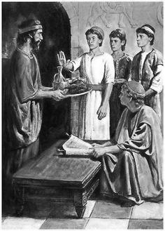
Daniel 1:14 So he consented to them in this matter, and proved them ten days.
The testing for Daniel and his companions was along the line of their religion. They were commanded to be fed with royal dainties and wine from the king’s table.
A. His Test Was Directed Against His Religion
1. The Food and drink would be very attractive to the carnal nature
2. It most likely was not prepared kosher
3. It most likely was sacrifices to heathen gods
4. They knew that refusing would open them to ridicule
5. They knew it would cause them to be ceremonially defiled
B. Daniel asked the 'Prince of the Eunuchs' that he might not defile himself.
1. Asked for beans to eat
2. Asked for water to drink - And to be tested 10 days
C. God honored his request
1. Gave him favor with Melzar
2. Melzar granted the test even though it could mean his life
VII. The Result of the Test – God Honors A No “Compromising With the World” Stand
Daniel 1:15 And at the end of ten days their countenances appeared fairer and fatter in flesh than all the children which did eat the portion of the king’s meat.
Daniel 1:16 Thus Melzar took away the portion of their meat, and the wine that they should drink; and gave them pulse.
Daniel 1:17 As for these four children, God gave them knowledge and skill in all learning and wisdom: and Daniel had understanding in all visions and dreams.
Today, we need to make this same type of “Purposeful Resolution” as Paul Instructs:
Romans 12:1 I beseech you therefore, brethren, by the mercies of God, that ye present your bodies a living sacrifice, holy, acceptable unto God, which is your reasonable service.
Romans 12:2 And be not conformed to this world: but be ye transformed by the renewing of your mind, that ye may prove what is that good, and acceptable, and perfect, will of God.
Romans 12:3 For I say, through the grace given unto me, to every man that is among you, not to think of himself more highly than he ought to think; but to think soberly, according as God hath dealt to every man the measure of faith.
Romans 12:4 For as we have many members in one body, and all members have not the same office:
Romans 12:5 So we, being many, are one body in Christ, and every one members one of another.
Romans 12:6 Having then gifts differing according to the grace that is given to us, whether prophecy, let us prophesy according to the proportion of faith;
Romans 12:7 Or ministry, let us wait on our ministering: or he that teacheth, on teaching;
Romans 12:8 Or he that exhorteth, on exhortation: he that giveth, let him do it with simplicity; he that ruleth, with diligence; he that sheweth mercy, with cheerfulness.
Romans 12:9 Let love be without dissimulation. Abhor that which is evil; cleave to that which is good.
Romans 12:10 Be kindly affectioned one to another with brotherly love; in honour preferring one another;
Romans 12:11 Not slothful in business; fervent in spirit; serving the Lord;
Romans 12:12 Rejoicing in hope; patient in tribulation; continuing instant in prayer;
Romans 12:13 Distributing to the necessity of saints; given to hospitality.
Romans 12:14 Bless them which persecute you: bless, and curse not.
Romans 12:15 Rejoice with them that do rejoice, and weep with them that weep.
Romans 12:16 Be of the same mind one toward another. Mind not high things, but condescend to men of low estate. Be not wise in your own conceits.

