And Let Him that is Athirst Come
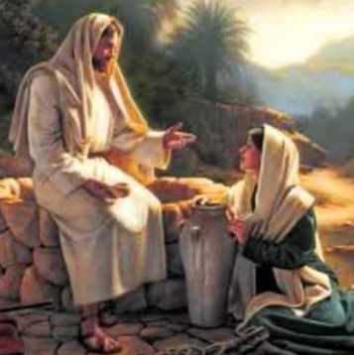 | John 4:13 …Whosoever drinketh of this water shall thirst again:  John 4:14 But whosoever drinketh of the water that I shall give him shall never thirst; but the water that I shall give him shall be in him a well of water springing up into everlasting life.  John 7:38 He that believeth on me, as the scripture hath said, out of his belly shall flow rivers of living water.  John 7:39 (But this spake he of the Spirit, which they that believe on him should receive: for the Holy Ghost was not yet given; because that Jesus was not yet glorified.)
I Corinthians 10:1 Moreover, brethren, I would not that ye should be ignorant, how that all our fathers were under the cloud, and all passed through the sea;  I Corinthians 10:2 And were all baptized unto Moses in the cloud and in the sea;  I Corinthians 10:3 And did all eat the same spiritual meat;  I Corinthians 10:4 And did all drink the same spiritual drink: for they drank of that spiritual Rock that followed them: and that Rock was Christ.  I Corinthians 10:5 But with many of them God was not well pleased: for they were overthrown in the wilderness.  I Corinthians 10:6 Now these things were our examples, to the intent we should not lust after evil things, as they also lusted. | 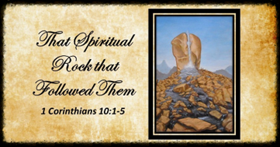
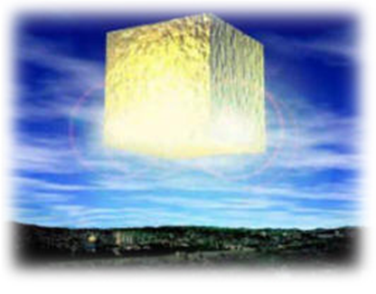 | Revelation 22:17 And the Spirit and the bride say, Come. And let him that heareth say, Come. And let him that is athirst come. And whosoever will, let him take the water of life freely.
Transition from Kingdom to Eternity – Leave Chapter 20, We Transition from Time to Eternity
In chapter 20, the last thing mentioned was hell. Chapter 21 teaches us about heaven. I’ve noticed that lately people do not talk much about heaven anymore. Several years ago, someone that loves to bring people to Christ, when I mentioned heaven, this person told me that he never mentions heaven when he evangelizes. He then said, “I do not want to offer them a “pie in the sky”, I only focus on the here and now.” Many Scripture Passages could come to mind concerning this, but one verse stands out in my mind: I Corinthians 15:19 If in this life only we have hope in Christ, we are of all men most miserable.
Have you ever heard one say something like: “He is so heavenly minded, he is no earthly good”? That seems to fly right in the face of Scripture that reads:
Colossians 1:1 If ye then be risen with Christ, seek those things which are above, where Christ sitteth on the right hand of God.
Colossians 1:2 Set your affection on things above, not on things on the earth.
Colossians 1:3 For ye are dead, and your life is hid with Christ in God.
Colossians 1:4 When Christ, who is our life, shall appear, then shall ye also appear with him in glory.
Colossians 1:5 Mortify therefore your members which are upon the earth; fornication, uncleanness, inordinate affection, evil concupiscence, and covetousness, which is idolatry:
Colossians 1:6 For which things’ sake the wrath of God cometh on the children of disobedience:
And Philippians 3:18 (For many walk, of whom I have told you often, and now tell you even weeping, that they are the enemies of the cross of Christ:
Philippians 3:19 Whose end is destruction, whose God is their belly, and whose glory is in their shame, who mind earthly things.)
Philippians 3:20 For our conversation is in heaven; from whence also we look for the Saviour, the Lord Jesus Christ:
And I Corinthians 6:9 Know ye not that the unrighteous shall not inherit the kingdom of God?
And Matthew 24:35 Heaven and earth shall pass away, but my words shall not pass away.
If we have this Biblical perspective, we would make all our decisions, conversation, and even politics based on the eternal Word of God, not the thoughts and teaching of the unrighteous who will never inherit heaven. Why would we base our decisions on their worldly philosophy or news programs?
Like the 2nd Advent is mentioned over 500 times in the Bible, so heaven is mentioned over 500 times and 55 times in the Book of Revelation alone. This chapter 21 is all about heaven. Let’s study about heaven in the Book of Revelation:
- The First Heaven and Earth were passed away
Revelation 21:1 And I saw a new heaven and a new earth: for the first heaven and the first earth were passed away; and there was no more sea.
- Isaiah prophesied concerning the New Heaven and New Earth and that we will rejoice forever
Isaiah 65:17 For, behold, I create new heavens and a new earth: and the former shall not be remembered, nor come into mind.
Isaiah 65:18 But be ye glad and rejoice for ever in that which I create: for, behold, I create Jerusalem a rejoicing, and her people a joy.

- Peter looks toward this same time teaching us that we should look for and hasten unto it
II Peter 3:10 But the day of the Lord will come as a thief in the night; in the which the heavens shall pass away with a great noise, and the elements shall melt with fervent heat, the earth also and the works that are therein shall be burned up.
II Peter 3:11 Seeing then that all these things shall be dissolved, what manner of persons ought ye to be in all holy conversation and godliness,
II Peter 3:12 Looking for and hasting unto the coming of the day of God, wherein the heavens being on fire shall be dissolved, and the elements shall melt with fervent heat?
II Peter 3:13 Nevertheless we, according to his promise, look for new heavens and a new earth, wherein dwelleth righteousness.

- John sees a city, New Jerusalem, coming down out of heaven, and compares it to a bride
Revelation 21:2 And I John saw the holy city, New Jerusalem, coming down from God out of heaven, prepared<2090> as a bride adorned for her husband.
- There are 3 heavens mentioned in Scripture – (II Corinthians 12:1-5)
- First heaven is our earth atmosphere
- Second heaven is outer pace
- Third heaven is where God dwells
- This is why John saw heaven destroyed and this city coming down “from God out of heaven”
- The New heaven and new earth is, I believe, the earth and it’s atmosphere
- “prepared” in verse two is the same verb Jesus used twice about His bride’s dwelling place
John 14:1 Let not your heart be troubled: ye believe in God, believe also in me.
John 14:2 In my Father’s house are many mansions: if it were not so, I would have told you. I go to prepare<2090> a place for you.
John 14:3 And if I go and prepare<2090> a place for you, I will come again, and receive you unto myself; that where I am, there ye may be also.
- <2090> is metoidzo “prepare or adorn in English”
- Verse 2 of Revelation 21` is the fulfillment of John 14:1-3. He comes to get us at the Rapture

- This city sparkles with beauty, but there is another reason this city is so spectacular-Next verse:
Revelation 21:3 And I heard a great voice out of heaven saying, Behold, the tabernacle of God is with men, and he will dwell with them, and they shall be his people, and God himself shall be with them, and be their God.
- It is spectacular because Christ is there
- Christ has “Metoidzo” this city for the bride He loves – He has been adorning it for 2000 years
- Remember the verse in Psalm 45 about the marriage of the Lamb?
Psalm 45:10 Hearken, O daughter, and consider, and incline thine ear; forget also thine own people, and thy father’s house;
Psalm 45:11 So shall the king greatly desire thy beauty: for he is thy Lord; and worship thou him.
- It is spectacular because the tabernacle (tent or dwelling) of God is with men
- This gets into the reason for creation – God has always wanted fellowship with man.
- The evidence of this goes back to the Garden of Eden, The Tabernacle, Temple, Church Age,
Tribulation, Kingdom, and finally in the New Heavens and Earth.
(See Chart on Reverse side)
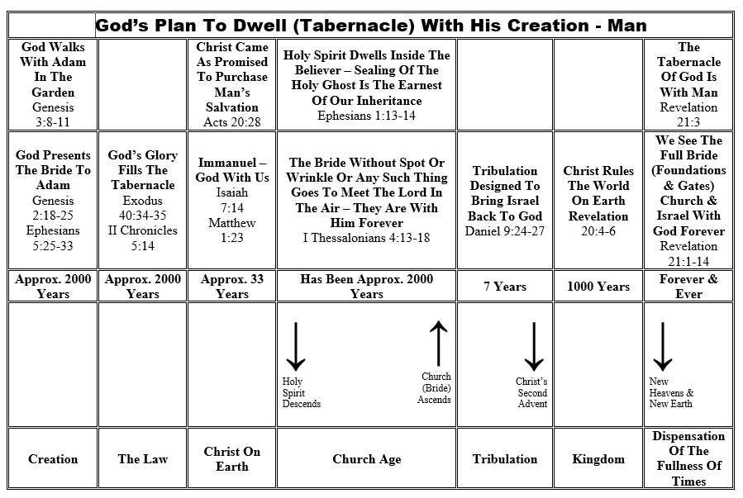
Revelation 21:4 And God shall wipe away all tears from their eyes; and there shall be no more death, neither sorrow, nor crying, neither shall there be any more pain: for the former things are passed away.
Revelation 21:5 And he that sat upon the throne said, Behold, I make all things new. And he said unto me, Write: for these words are true and faithful.
Revelation 21:6 And he said unto me, It is done. I am Alpha and Omega, the beginning and the end. I will give unto him that is athirst of the fountain of the water of life freely.
- Alpha and Omega – First and last letters in Greek alphabet
- Jehovah’s Witnesses do not like this one – Shows Christ in Old Testament is Jehovah

Isaiah 41:6 Thus saith the LORD the King of Israel, and his redeemer the LORD of hosts; I am the first, and I am the last; and beside me there is no God.

- To him that is athirst of the fountain of the water of life freely
- Reminds me of Christ in Samaria:
John 4:5 Then cometh he to a city of Samaria, which is called Sychar, near to the parcel of ground that Jacob gave to his son Joseph.
John 4:6 Now Jacob’s well was there. Jesus therefore, being wearied with his journey, sat thus on the well: and it was about the sixth hour.
John 4:7 There cometh a woman of Samaria to draw water: Jesus saith unto her, Give me to drink.
John 4:8 (For his disciples were gone away unto the city to buy meat.)
John 4:9 Then saith the woman of Samaria unto him, How is it that thou, being a Jew, askest drink of me, which am a woman of Samaria? for the Jews have no dealings with the Samaritans.
John 4:10 Jesus answered and said unto her, If thou knewest the gift of God, and who it is that saith to thee, Give me to drink; thou wouldest have asked of him, and he would have given thee living water.
John 4:11 The woman saith unto him, Sir, thou hast nothing to draw with, and the well is deep: from whence then hast thou that living water?
John 4:12 Art thou greater than our father Jacob, which gave us the well, and drank thereof himself, and his children, and his cattle?
John 4:13 Jesus answered and said unto her, Whosoever drinketh of this water shall thirst again:
John 4:14 But whosoever drinketh of the water that I shall give him shall never thirst; but the water that I shall give him shall be in him a well of water springing up into everlasting life.
John 4:15 The woman saith unto him, Sir, give me this water, that I thirst not, neither come hither to draw.
John 4:16 Jesus saith unto her, Go, call thy husband, and come hither.
John 4:17 The woman answered and said, I have no husband. Jesus said unto her, Thou hast well said, I have no husband:
John 4:18 For thou hast had five husbands; and he whom thou now hast is not thy husband: in that saidst thou truly.
John 4:19 The woman saith unto him, Sir, I perceive that thou art a prophet.
20 Our fathers worshipped in this mountain; and ye say, that in Jerusalem is the place where men ought to worship.
John 4:21 Jesus saith unto her, Woman, believe me, the hour cometh, when ye shall neither in this mountain, nor yet at Jerusalem, worship the Father.
John 4:22 Ye worship ye know not what: we know what we worship: for salvation is of the Jews.
John 4:23 But the hour cometh, and now is, when the true worshippers shall worship the Father in spirit and in truth: for the Father seeketh such to worship him.
John 4:24 God is a Spirit: and they that worship him must worship him in spirit and in truth.
John 4:25 The woman saith unto him, I know that Messiahs cometh, which is called Christ: when he is come, he will tell us all things.
John 4:26 Jesus saith unto her, I that speak unto thee am he.
- This woman had a thirst (All do) this thirst was a God sized void in her soul
- She tried to fill this God-sized void with human relationships
- That may seem an act of reason, but is shallow and soon will not satisfy
- What she was thirsting for was the living water of the Holy Spirit – Only God can give

- Christ makes another statement concerning thirst and living water in John:

John 7:1 After these things Jesus walked in Galilee: for he would not walk in Jewry, because the Jews sought to kill him.
John 7:2 Now the Jews’ feast of tabernacles was at hand….

John 7:37 In the last day, that great day of the feast, Jesus stood and cried, saying, If any man thirst, let him come unto me, and drink.
John 7:38 He that believeth on me, as the scripture hath said, out of his belly shall flow rivers of living water.
John 7:39 (But this spake he of the Spirit, which they that believe on him should receive: for the Holy Ghost was not yet given; because that Jesus was not yet glorified.)
John 7:40 Many of the people therefore, when they heard this saying, said, Of a truth this is the Prophet.
John 7:41 Others said, This is the Christ. But some said, Shall Christ come out of Galilee?
John 7:42 Hath not the scripture said, That Christ cometh of the seed of David, and out of the town of Bethlehem, where David was?
John 7:43 So there was a division among the people because of him.
John 7:44 And some of them would

- Paul teaches the Corinthian church about this Spiritual drink – Israelites an example for us

I Corinthians 10:1 Moreover, brethren, I would not that ye should be ignorant, how that all our fathers were under the cloud, and all passed through the sea;
I Corinthians 10:2 And were all baptized unto Moses in the cloud and in the sea;
I Corinthians 10:3 And did all eat the same spiritual meat;
I Corinthians 10:4 And did all drink the same spiritual drink: for they drank of that spiritual Rock that followed them: and that Rock was Christ.
I Corinthians 10:5 But with many of them God was not well pleased: for they were overthrown in the wilderness.
I Corinthians 10:6 Now these things were our examples, to the intent we should not lust after evil things, as they also lusted.

- The People of the New Heaven and New Earth
Revelation 21:7 He that overcometh shall inherit all things; and I will be his God, and he shall be my son.
- The People that will NOT be of the New Heaven and New Earth

Revelation 21:8 But the fearful, and unbelieving, and the abominable, and murderers, and whoremongers, and sorcerers, and idolaters, and all liars, shall have their part in the lake which burneth with fire and brimstone: which is the second death.

- The “Bride” the “Lamb’s Wife Measured– Identified by its inhabitants

Revelation 21:9 And there came unto me one of the seven angels which had the seven vials full of the seven last plagues, and talked with me, saying, Come hither, I will shew thee the bride, the Lamb’s wife.
Revelation 21:10 And he carried me away in the spirit to a great and high mountain, and shewed me that great city, the holy Jerusalem, descending out of heaven from God,
Revelation 21:11 Having the glory of God: and her light was like unto a stone most precious, even like a jasper stone, clear as crystal;
Revelation 21:12 And had a wall great and high, and had twelve gates, and at the gates twelve angels, and names written thereon, which are the names of the twelve tribes of the children of Israel:
Revelation 21:13 On the east three gates; on the north three gates; on the south three gates; and on the west three gates.
Revelation 21:14 And the wall of the city had twelve foundations, and in them the names of the twelve apostles of the Lamb.
Revelation 21:15 And he that talked with me had a golden reed to measure the city, and the gates thereof, and the wall thereof.
Revelation 21:16 And the city lieth foursquare, and the length is as large as the breadth: and he measured the city with the reed, twelve thousand furlongs. The length and the breadth and the height of it are equal.

- 12000 furlong length, breadth, and height Cube – Round-off to 1500 Miles

New Jerusalem measured with Aerial View over United States
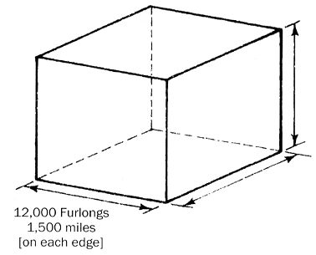

Revelation 21:17 And he measured the wall thereof, an hundred and forty and four cubits, according to the measure of a man, that is, of the angel.
- Walls of Precious Stones
Revelation 21:18 And the building of the wall of it was of jasper: and the city was pure gold, like unto clear glass.
Revelation 21:19 And the foundations of the wall of the city were garnished with all manner of precious stones. The first foundation was jasper; the second, sapphire; the third, a chalcedony; the fourth, an emerald;
Revelation 21:20 The fifth, sardonyx; the sixth, sardius; the seventh, chrysolite; the eighth, beryl; the ninth, a topaz; the tenth, a chrysoprasus; the eleventh, a jacinth; the twelfth, an amethyst.
Revelation 21:21 And the twelve gates were twelve pearls; every several gate was of one pearl: and the street of the city was pure gold, as it were transparent glass.

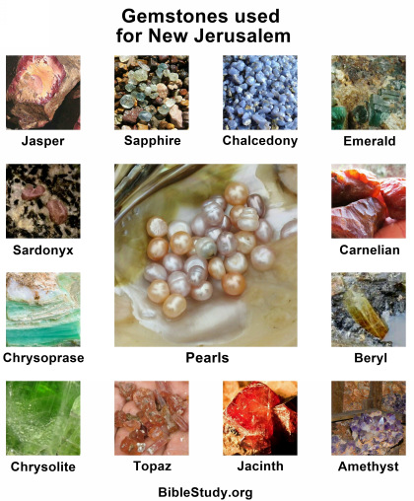

- Lord God Almighty and the Lamb are the temple of it.
Revelation 21:22 And I saw no temple therein: for the Lord God Almighty and the Lamb are the temple of it.
Revelation 21:23 And the city had no need of the sun, neither of the moon, to shine in it: for the glory of God did lighten it, and the Lamb is the light thereof.
Revelation 21:24 And the nations of them which are saved shall walk in the light of it: and the kings of the earth do bring their glory and honour into it.
Revelation 21:25 And the gates of it shall not be shut at all by day: for there shall be no night there.
Revelation 21:26 And they shall bring the glory and honour of the nations into it.
Revelation 21:27 And there shall in no wise enter into it any thing that defileth, neither whatsoever worketh abomination, or maketh a lie: but they which are written in the Lamb’s book of life.
- More Descriptions of New Jerusalem
Revelation 22:1 And he shewed me a pure river of water of life, clear as crystal, proceeding out of the throne of God and of the Lamb.
Revelation 22:2 In the midst of the street of it, and on either side of the river, was there the tree of life, which bare twelve manner of fruits, and yielded her fruit every month: and the leaves of the tree were for the healing of the nations.
Revelation 22:3 And there shall be no more curse: but the throne of God and of the Lamb shall be in it; and his servants shall serve him:
Revelation 22:4 And they shall see his face; and his name shall be in their foreheads.
Revelation 22:5 And there shall be no night there; and they need no candle, neither light of the sun; for the Lord God giveth them light: and they shall reign for ever and ever.
- Seal not the Sayings of the Prophecy of this Book
Revelation 22:6 And he said unto me, These sayings are faithful and true: and the Lord God of the holy prophets sent his angel to shew unto his servants the things which must shortly be done.
Revelation 22:7 Behold, I come quickly: blessed is he that keepeth the sayings of the prophecy of this book.
Revelation 22:8 And I John saw these things, and heard them. And when I had heard and seen, I fell down to worship before the feet of the angel which shewed me these things.
Revelation 22:9 Then saith he unto me, See thou do it not: for I am thy fellowservant, and of thy brethren the prophets, and of them which keep the sayings of this book: worship God.
Revelation 22:10 And he saith unto me, Seal not the sayings of the prophecy of this book: for the time is at hand.
Revelation 22:11 He that is unjust, let him be unjust still: and he which is filthy, let him be filthy still: and he that is righteous, let him be righteous still: and he that is holy, let him be holy still.
Revelation 22:12 And, behold, I come quickly; and my reward is with me, to give every man according as his work shall be.
Revelation 22:13 I am Alpha and Omega, the beginning and the end, the first and the last.
Revelation 22:14 Blessed are they that do his commandments that they may have right to the tree of life, and may enter in through the gates into the city.
Revelation 22:15 For without are dogs, and sorcerers, and whoremongers, and murderers, and idolaters, and whosoever loveth and maketh a lie.
Revelation 22:16 I Jesus have sent mine angel to testify unto you these things in the churches. I am the root and the offspring of David, and the bright and morning star.
- Let him that is athirst come. And whosoever will, let him take the water of life freely
Revelation 22:17 And the Spirit and the bride say, Come. And let him that heareth say, Come. And let him that is athirst come. And whosoever will, let him take the water of life freely.
Revelation 22:18 For I testify unto every man that heareth the words of the prophecy of this book, If any man shall add unto these things, God shall add unto him the plagues that are written in this book:
Revelation 22:19 And if any man shall take away from the words of the book of this prophecy, God shall take away his part out of the book of life, and out of the holy city, and from the things which are written in this book.
Revelation 22:20 He which testifieth these things saith, Surely I come quickly. Amen. Even so, come, Lord Jesus.
Revelation 22:21 The grace of our Lord Jesus Christ be with you all. Amen.

