How Shall We Escape, If We Neglect So Great Salvation

Hebrews 3:10 Wherefore I was grieved with that generation, and said, They do alway err in their heart; and they have not known my ways.  Hebrews 3:11 So I sware in my wrath, They shall not enter into my rest.)  Hebrews 3:12 Take heed, brethren, lest there be in any of you an evil heart of unbelief, in departing from the living God. | 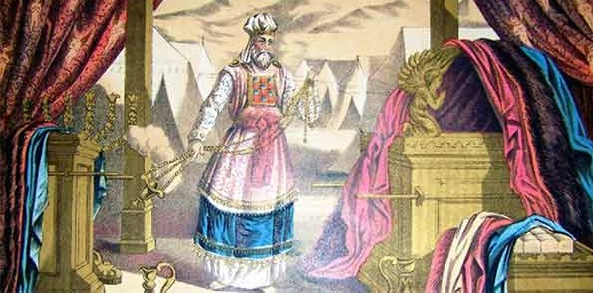
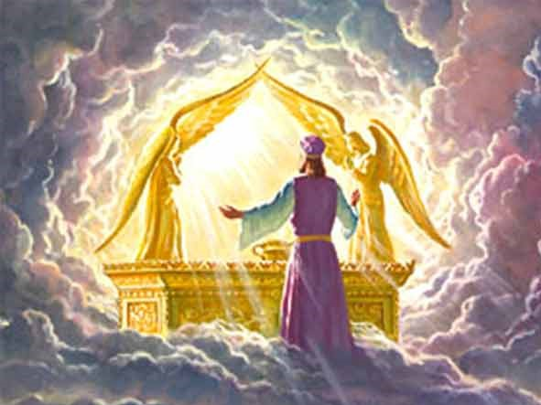 | Hebrews 3:13 But exhort one another daily, while it is called To day; lest any of you be hardened through the deceitfulness of sin.  Hebrews 3:14 For we are made partakers of Christ, if we hold the beginning of our confidence stedfast unto the end;  Hebrews 3:15 While it is said, Today if ye will hear his voice, harden not your hearts, as in the provocation.  Hebrews 3:16 For some, when they had heard, did provoke: howbeit not all that came
Hebrews 10:14 Seeing then that we have a great high priest, that is passed into the heavens, Jesus the Son of God, let us hold fast our profession.  Hebrews 10:15 For we have not an high priest which cannot be touched with the feeling of our infirmities; but was in all points tempted like as we are, yet without sin.  Hebrews 10:16 Let us therefore come boldly unto the throne of grace, that we may obtain mercy, and find grace to help in time of need. | 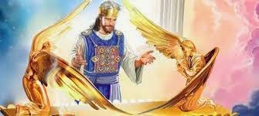

Hebrews Chapter 2-4 – Departing from the Living God

Seeing then that We Have a Great High Priest, Have Not an evil heart of unbelief, in Departing from the Living God.

Psalm 95:1 O come, let us sing unto the LORD: let us make a joyful noise to the rock of our salvation.
Psalm 95:2 Let us come before his presence with thanksgiving, and make a joyful noise unto him with psalms.
Psalm 95:3 For the LORD is a great God, and a great King above all gods.
Psalm 95:4 In his hand are the deep places of the earth: the strength of the hills is his also.
Psalm 95:5 The sea is his, and he made it: and his hands formed the dry land.
Psalm 95:6 O come, let us worship and bow down: let us kneel before the LORD our maker.
Psalm 95:7 For he is our God; and we are the people of his pasture, and the sheep of his hand. To day if ye will hear his voice,
Psalm 95:8 Harden not your heart, as in the provocation, and as in the day of temptation in the wilderness:
Psalm 95:9 When your fathers tempted me, proved me, and saw my work.
Psalm 95:10 Forty years long was I grieved with this generation, and said, It is a people that do err in their heart, and they have not known my ways:
Psalm 95:11 Unto whom I sware in my wrath that they should not enter into my rest.

- We ought to give the more Earnest Heed

Hebrews 2:1 ¶ Therefore we ought to give the more earnest heed to the things which we have heard, lest at any time we should let them slip.
Hebrews 2:2 For if the word spoken by angels was stedfast, and every transgression and disobedience received a just recompence of reward;

- We will not escape if we neglect the Word

Hebrews 2:3 How shall we escape, if we neglect so great salvation; which at the first began to be spoken by the Lord, and was confirmed unto us by them that heard him;
Hebrews 2:4 God also bearing them witness, both with signs and wonders, and with divers miracles, and gifts of the Holy Ghost, according to his own will?

- The angels are not going to rule in the world to come (The Kingdom)

Hebrews 2:5 For unto the angels hath he not put in subjection the world to come, whereof we speak.

- What is man that God should even consider him?

Hebrews 2:6 But one in a certain place testified, saying, What is man, that thou art mindful of him? or the son of man, that thou visitest him?
Hebrews 2:7 Thou madest him a little lower than the angels; thou crownedst him with glory and honour, and didst set him over the works of thy hands:
Hebrews 2:8 Thou hast put all things in subjection under his feet. For in that he put all in subjection under him, he left nothing that is not put under him. But now we see not yet all things put under him.

- But we see Jesus

Hebrews 2:9 But we see Jesus, who was made a little lower than the angels for the suffering of death, crowned with glory and honour; that he by the grace of God should taste death for every man.
Hebrews 2:10 For it became him, for whom are all things, and by whom are all things, in bringing many sons unto glory, to make the captain of their salvation perfect through sufferings.

- The Sanctifier is not ashamed to call the Church Brethren

Hebrews 2:11 For both he that sanctifieth and they who are sanctified are all of one: for which cause he is not ashamed to call them brethren,

Hebrews 10:10 By the which will we are sanctified through the offering of the body of Jesus Christ once for all.

Hebrews 2:12 Saying, I will declare thy name unto my brethren, in the midst of the church will I sing praise unto thee.

Psalm 22: 22 I will declare thy name unto my brethren: in the midst of the congregation will I praise thee.

- Through Death, The Sanctifier Destroyed the one that had the Power of Death

Hebrews 2:13 And again, I will put my trust in him. And again, Behold I and the children which God hath given me.
Hebrews 2:14 ¶ Forasmuch then as the children are partakers of flesh and blood, he also himself likewise took part of the same; that through death he might destroy him that had the power of death, that is, the devil;
Hebrews 2:15 And deliver them who through fear of death were all their lifetime subject to bondage.

- The Sanctifier Accomplished this by Taking Upon Himself the Seed of Abraham

Hebrews 2:16 For verily he took not on him the nature of angels; but he took on him the seed of Abraham.

- It Behoved Him to be made like His brethren

Hebrews 2:17 Wherefore in all things it behoved him to be made like unto his brethren, that he might be a merciful and faithful high priest in things pertaining to God, to make reconciliation for the sins of the people.
Hebrews 2:18 For in that he himself hath suffered being tempted, he is able to succour them that are tempted.

Philippians 2:7 But made himself of no reputation, and took upon him the form of a servant, and was made in the likeness of men:
Philippians 2:8 And being found in fashion as a man, he humbled himself, and became obedient unto death, even the death of the cross.
- Behoved, Ophielo, can mean owe, ought, or duty according to the context. While Christ does not owe us anything, Christ had made a promise to Abraham – A promise of a Seed and world-wide blessing. He will reclaim the land during the Tribulation period. The next 2 verses explains this by stating that “He is faithful to Him that “appointed Him”.

- Consider Jesus

- The Apostle of our profession

Hebrews 3:1 Wherefore, holy brethren, partakers of the heavenly calling, consider the Apostle and High Priest of our profession, Christ Jesus;

- Christ was faithful to the Father – Moses was faithful in all His House

Hebrews 3:2 Who was faithful to him that appointed him, as also Moses was faithful in all his house.

- Whereas Christ is worthy of more glory than Moses

Hebrews 3:3 For this man was counted worthy of more glory than Moses, inasmuch as he who hath builded the house hath more honour than the house.
Hebrews 3:4 For every house is builded by some man; but he that built all things is God.

- But Christ was worthy of more glory over His own house

Hebrews 3:5 And Moses verily was faithful in all his house, as a servant, for a testimony of those things which were to be spoken after;
Hebrews 3:6 But Christ as a son over his own house; whose house are we, if we hold fast the confidence and the rejoicing of the hope firm unto the end.

- We are His House - IF:
- We Hold Fast the Confidence
- And the rejoicing of the hope Firm to the End

Hebrews 3:7 Wherefore (as the Holy Ghost saith, Today if ye will hear his voice,
Hebrews 3:8 Harden not your hearts, as in the provocation, in the day of temptation in the wilderness:
Hebrews 3:9 When your fathers tempted me, proved me, and saw my works forty years.
Hebrews 3:10 Wherefore I was grieved with that generation, and said, They do alway err in their heart; and they have not known my ways.
Hebrews 3:11 So I sware in my wrath, They shall not enter into my rest.)

- Take heed to not have an “evil heart of unbelief”, causing us to Depart from the Living God.

Hebrews 3:12 Take heed, brethren, lest there be in any of you an evil heart of unbelief, in departing from the living God.
Hebrews 3:13 But exhort one another daily, while it is called To day; lest any of you be hardened through the deceitfulness of sin.

- Notice how we are made partakers of Christ

Hebrews 3:14 For we are made partakers of Christ, if we hold the beginning of our confidence stedfast unto the end;

- Let us not harden our hearts as the Israelites did in the desert

Hebrews 3:15 While it is said, To day if ye will hear his voice, harden not your hearts, as in the provocation.
Hebrews 3:16 For some, when they had heard, did provoke: howbeit not all that came out of Egypt by Moses.
Hebrews 3:17 But with whom was he grieved forty years? was it not with them that had sinned, whose carcases fell in the wilderness?
Hebrews 3:18 And to whom sware he that they should not enter into his rest, but to them that believed not?
Hebrews 3:19 So we see that they could not enter in because of unbelief.

- Don’t Fall short of the promise – Mix the promise with faith

Hebrews 4:1 Let us therefore fear, lest, a promise being left us of entering into his rest, any of you should seem to come short of it.
Hebrews 4:2 For unto us was the gospel preached, as well as unto them: but the word preached did not profit them, not being mixed with faith in them that heard it.
Hebrews 4:3 For we which have believed do enter into rest, as he said, As I have sworn in my wrath, if they shall enter into my rest: although the works were finished from the foundation of the world.
Hebrews 4:4 For he spake in a certain place of the seventh day on this wise, And God did rest the seventh day from all his works.
Hebrews 4:5 And in this place again, If they shall enter into my rest.
Hebrews 4:6 Seeing therefore it remaineth that some must enter therein, and they to whom it was first preached entered not in because of unbelief:

- He That Has Entered Into His Rest Hath Ceased From His Own Works

Hebrews 4:7 Again, he limiteth a certain day, saying in David, To day, after so long a time; as it is said, To day if ye will hear his voice, harden not your hearts.
Hebrews 4:8 For if Jesus had given them rest, then would he not afterward have spoken of another day.
Hebrews 4:9 There remaineth therefore a rest to the people of God.
Hebrews 4:10 For he that is entered into his rest, he also hath ceased from his own works, as God did from his.

- Let Us Labor to Enter Into That Rest

Hebrews 4:11 Let us labour therefore to enter into that rest, lest any man fall after the same example of unbelief.

- This sounds like the Blessing that Joshua gave the Children of Israel after they had crossed the Jordan:
Joshua 22:1 Then Joshua called the Reubenites, and the Gadites, and the half tribe of Manasseh,
Joshua 22:2 And said unto them, Ye have kept all that Moses the servant of the LORD commanded you, and have obeyed my voice in all that I commanded you:
Joshua 22:3 Ye have not left your brethren these many days unto this day, but have kept the charge of the commandment of the LORD your God.
Joshua 22:4 And now the LORD your God hath given rest unto your brethren, as he promised them: therefore now return ye, and get you unto your tents, and unto the land of your possession, which Moses the servant of the LORD gave you on the other side Jordan.
Joshua 22:5 But take diligent heed to do the commandment and the law, which Moses the servant of the LORD charged you, to love the LORD your God, and to walk in all his ways, and to keep his commandments, and to cleave unto him, and to serve him with all your heart and with all your soul.

- The Answer is to take heed not to let the Saving Words spoken by the Son Slip from you

Hebrews 4:12 For the word of God is quick, and powerful, and sharper than any twoedged sword, piercing even to the dividing asunder of soul and spirit, and of the joints and marrow, and is a discerner of the thoughts and intents of the heart.

- Christ Sees Every Move We Make

Hebrews 4:13 Neither is there any creature that is not manifest in his sight: but all things are naked and opened unto the eyes of him with whom we have to do.

- We Have A Great High Priest – Let Us Come Boldly to the Throne – Obtain Mercy and find Grace to help in time of need.

Hebrews 4:14 Seeing then that we have a great high priest, that is passed into the heavens, Jesus the Son of God, let us hold fast our profession.
Hebrews 4:15 For we have not an high priest which cannot be touched with the feeling of our infirmities; but was in all points tempted like as we are, yet without sin.
Hebrews 4:16 Let us therefore come boldly unto the throne of grace, that we may obtain mercy, and find grace to help in time of need.

